Git repo URL:
https://github.com/Shanmugapriya2390/Trend-DevOps-Project
Load balancer ARN:
ac278cade4af74cf5948dcb3d6364a0f-1809302923.ap-south-1.elb.amazonaws.com

Git clone
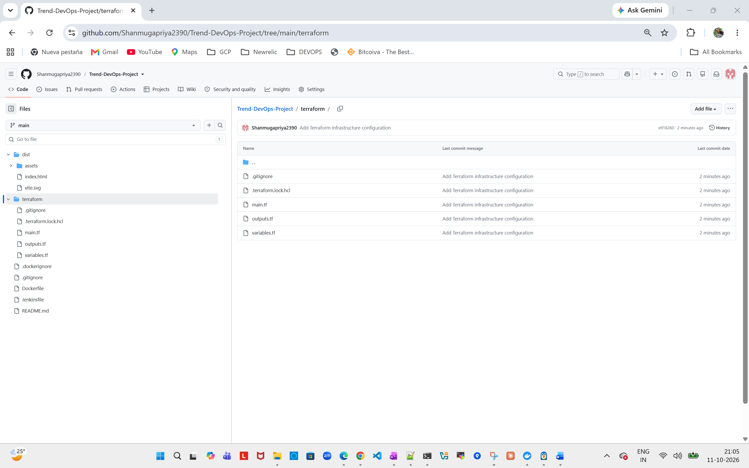

Docker File Creation:
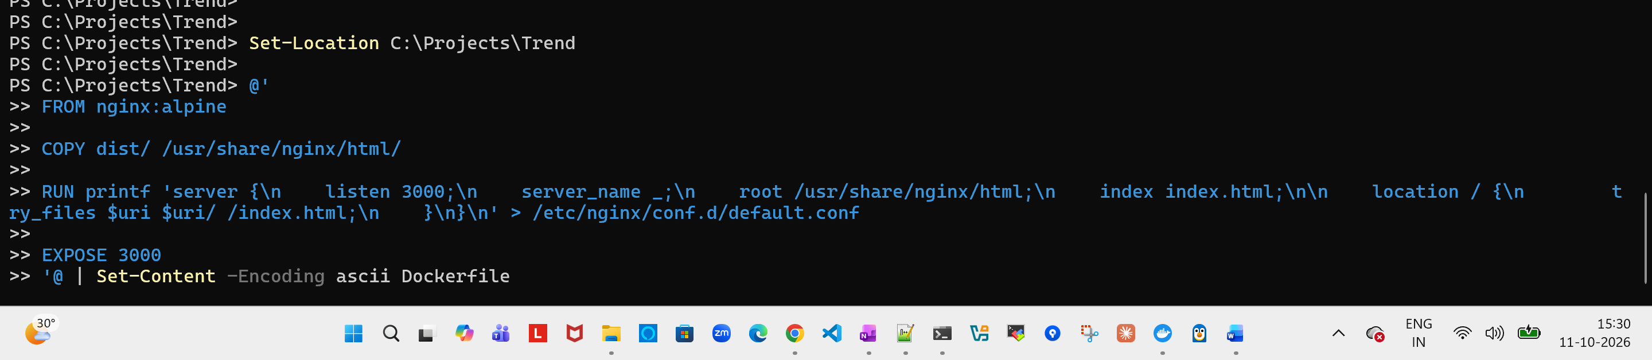
Dockerfile
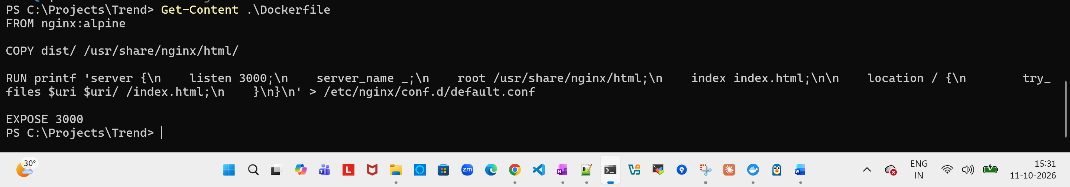
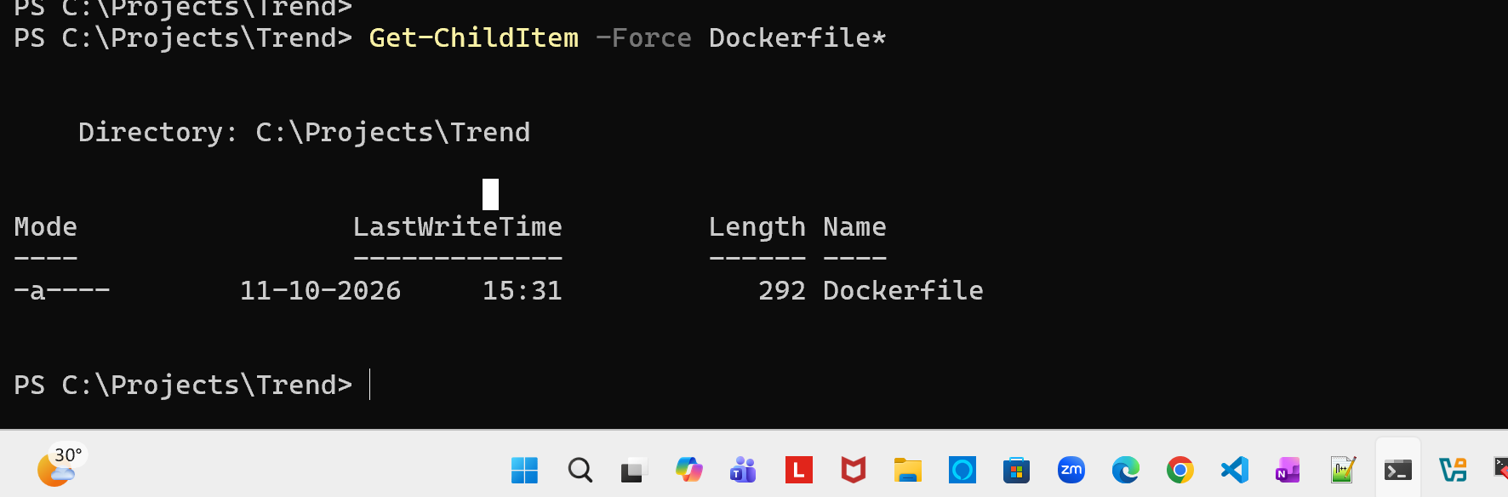
Gitignore & dockerignore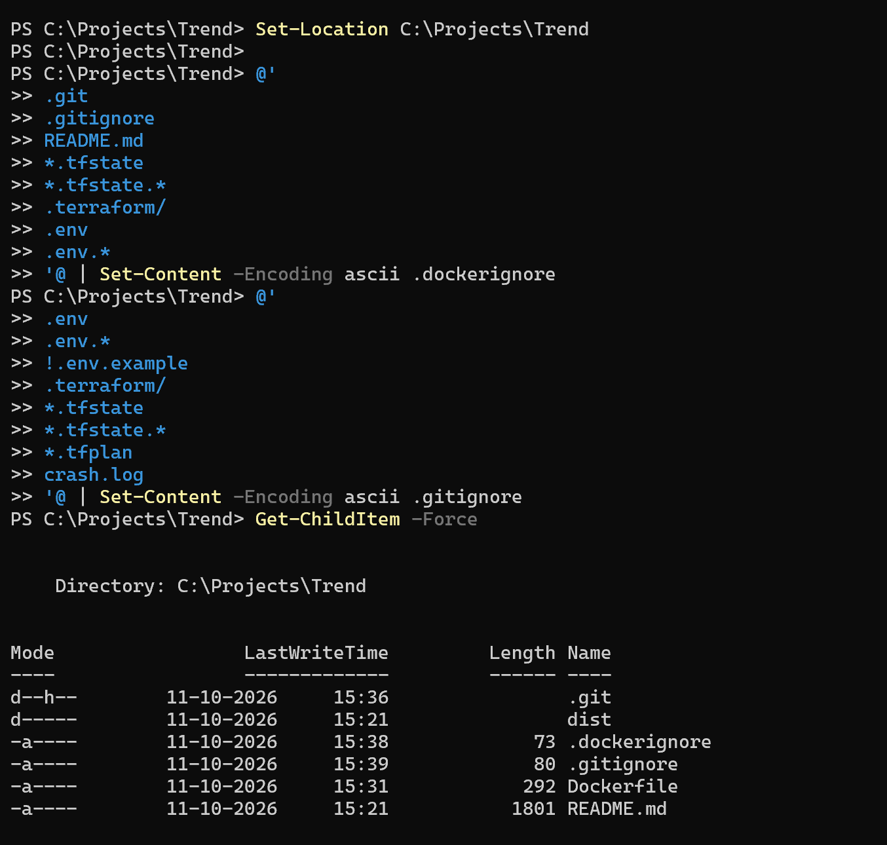

Build docker image:
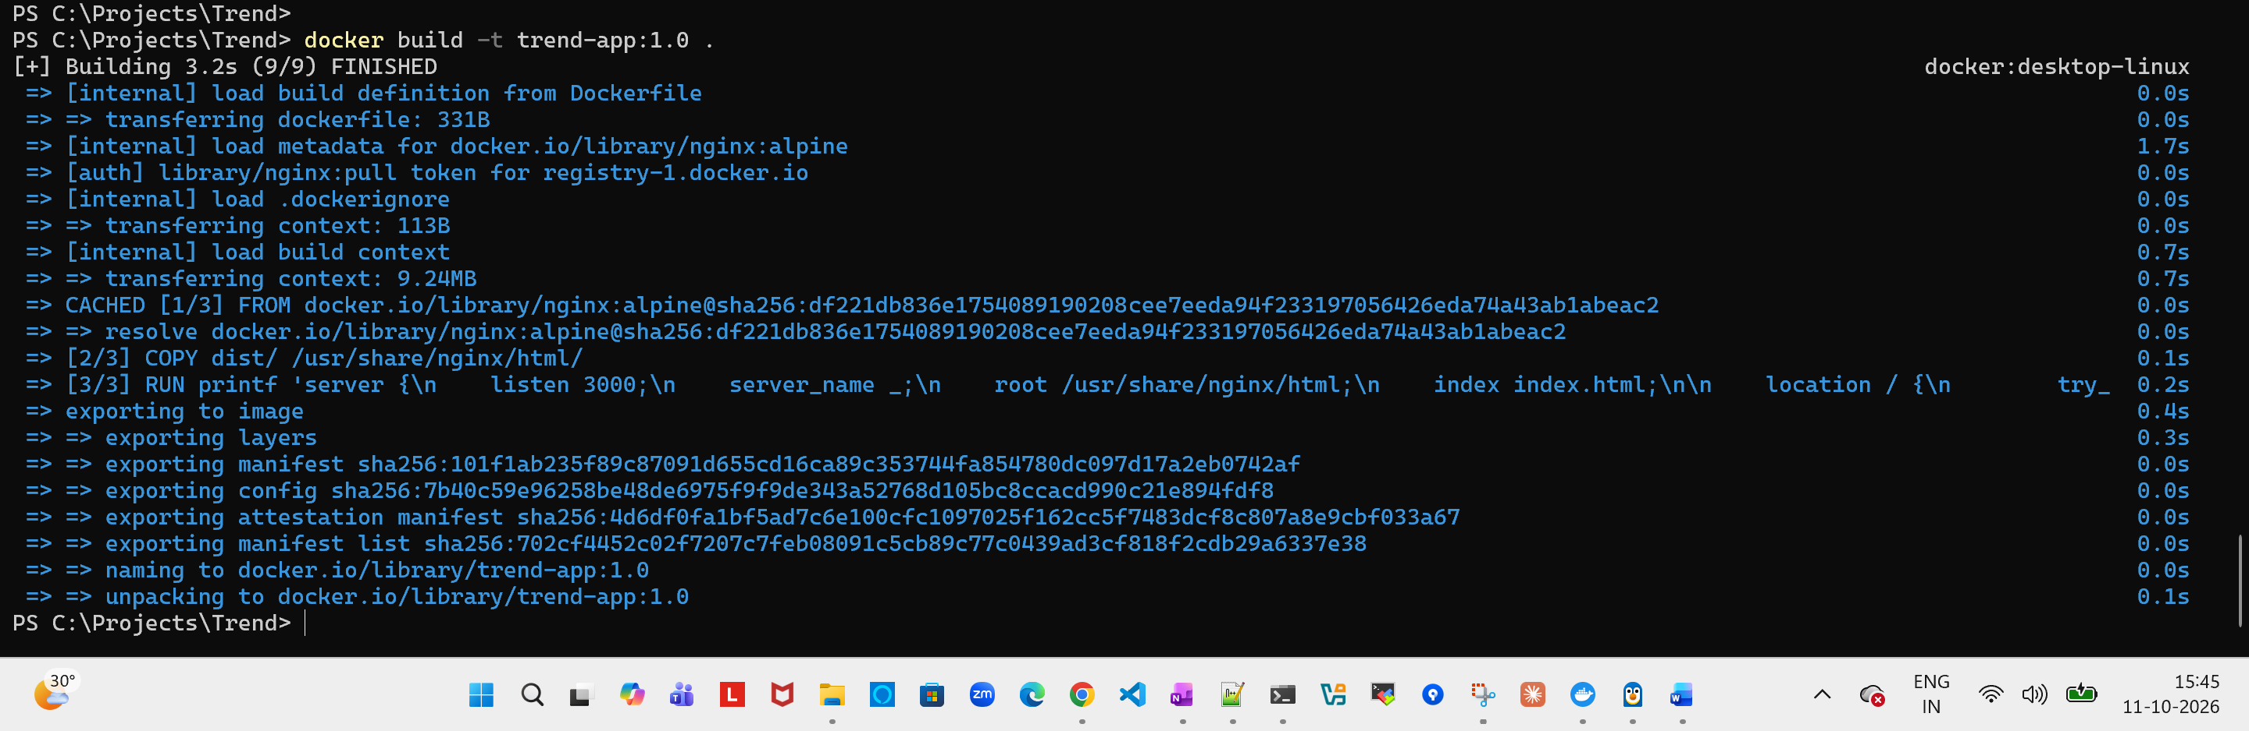
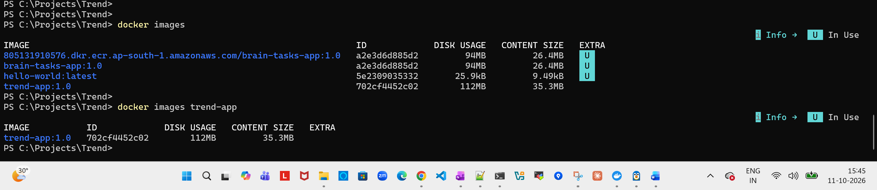

Start the application:
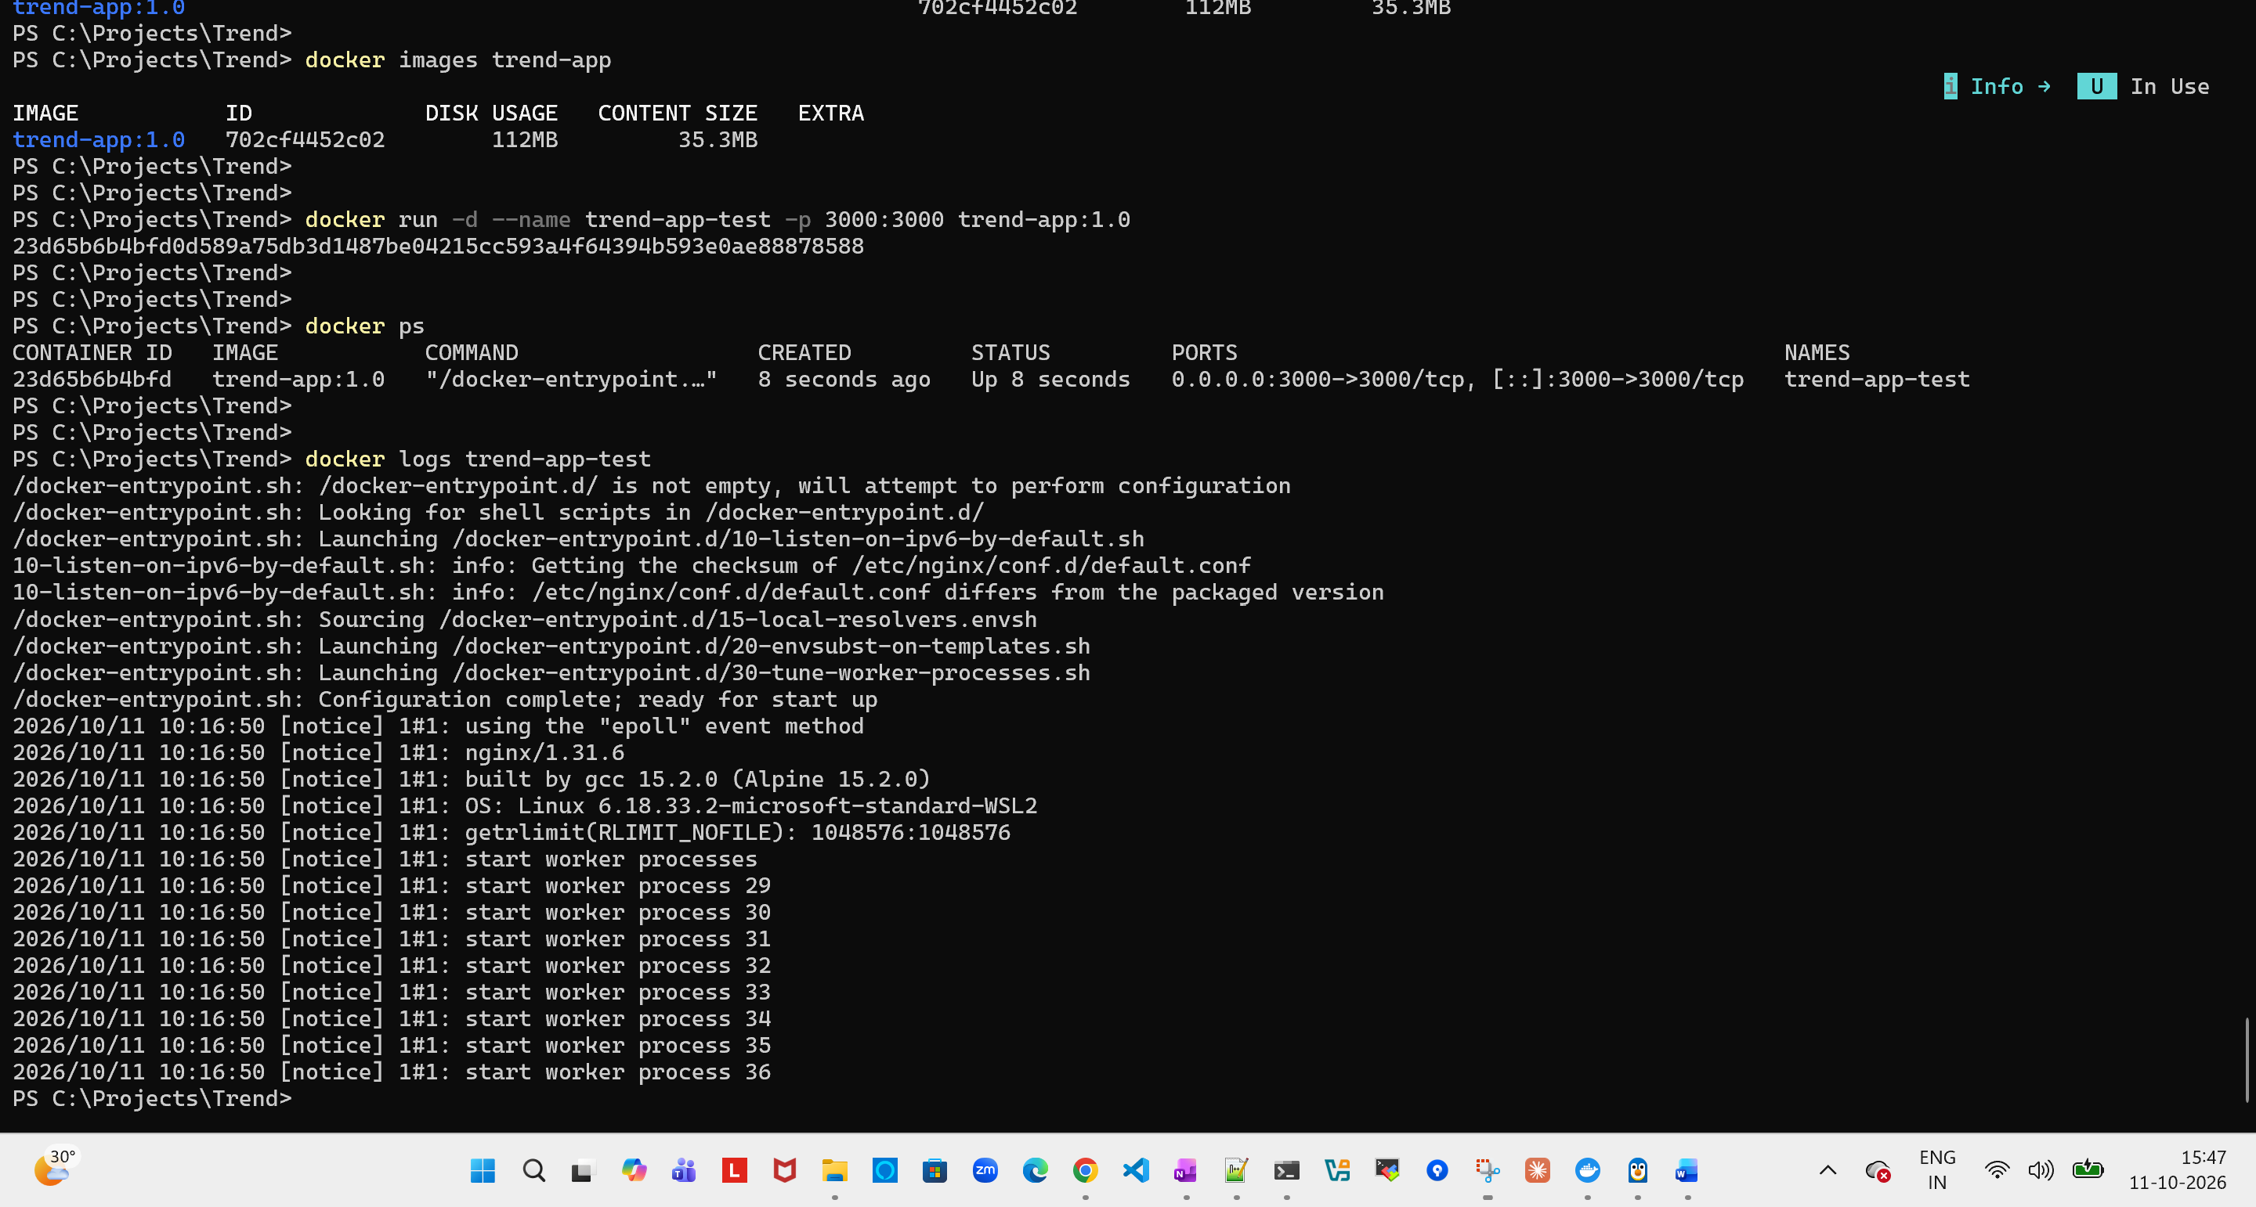

POC check:
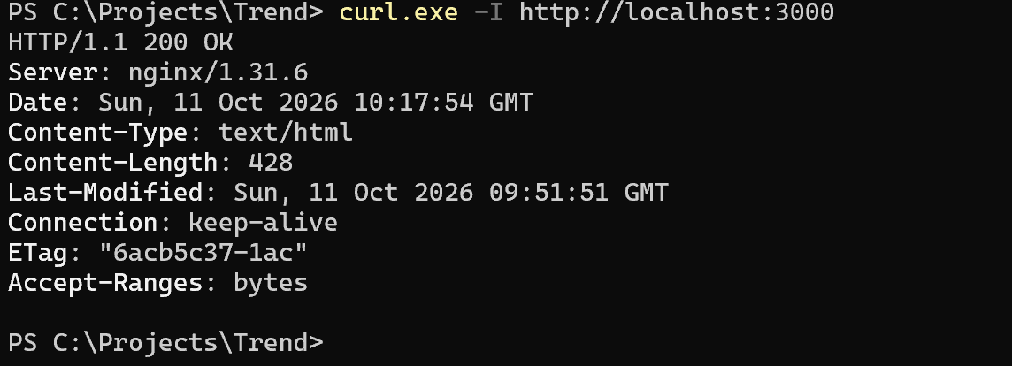

Docker Hub Creation:

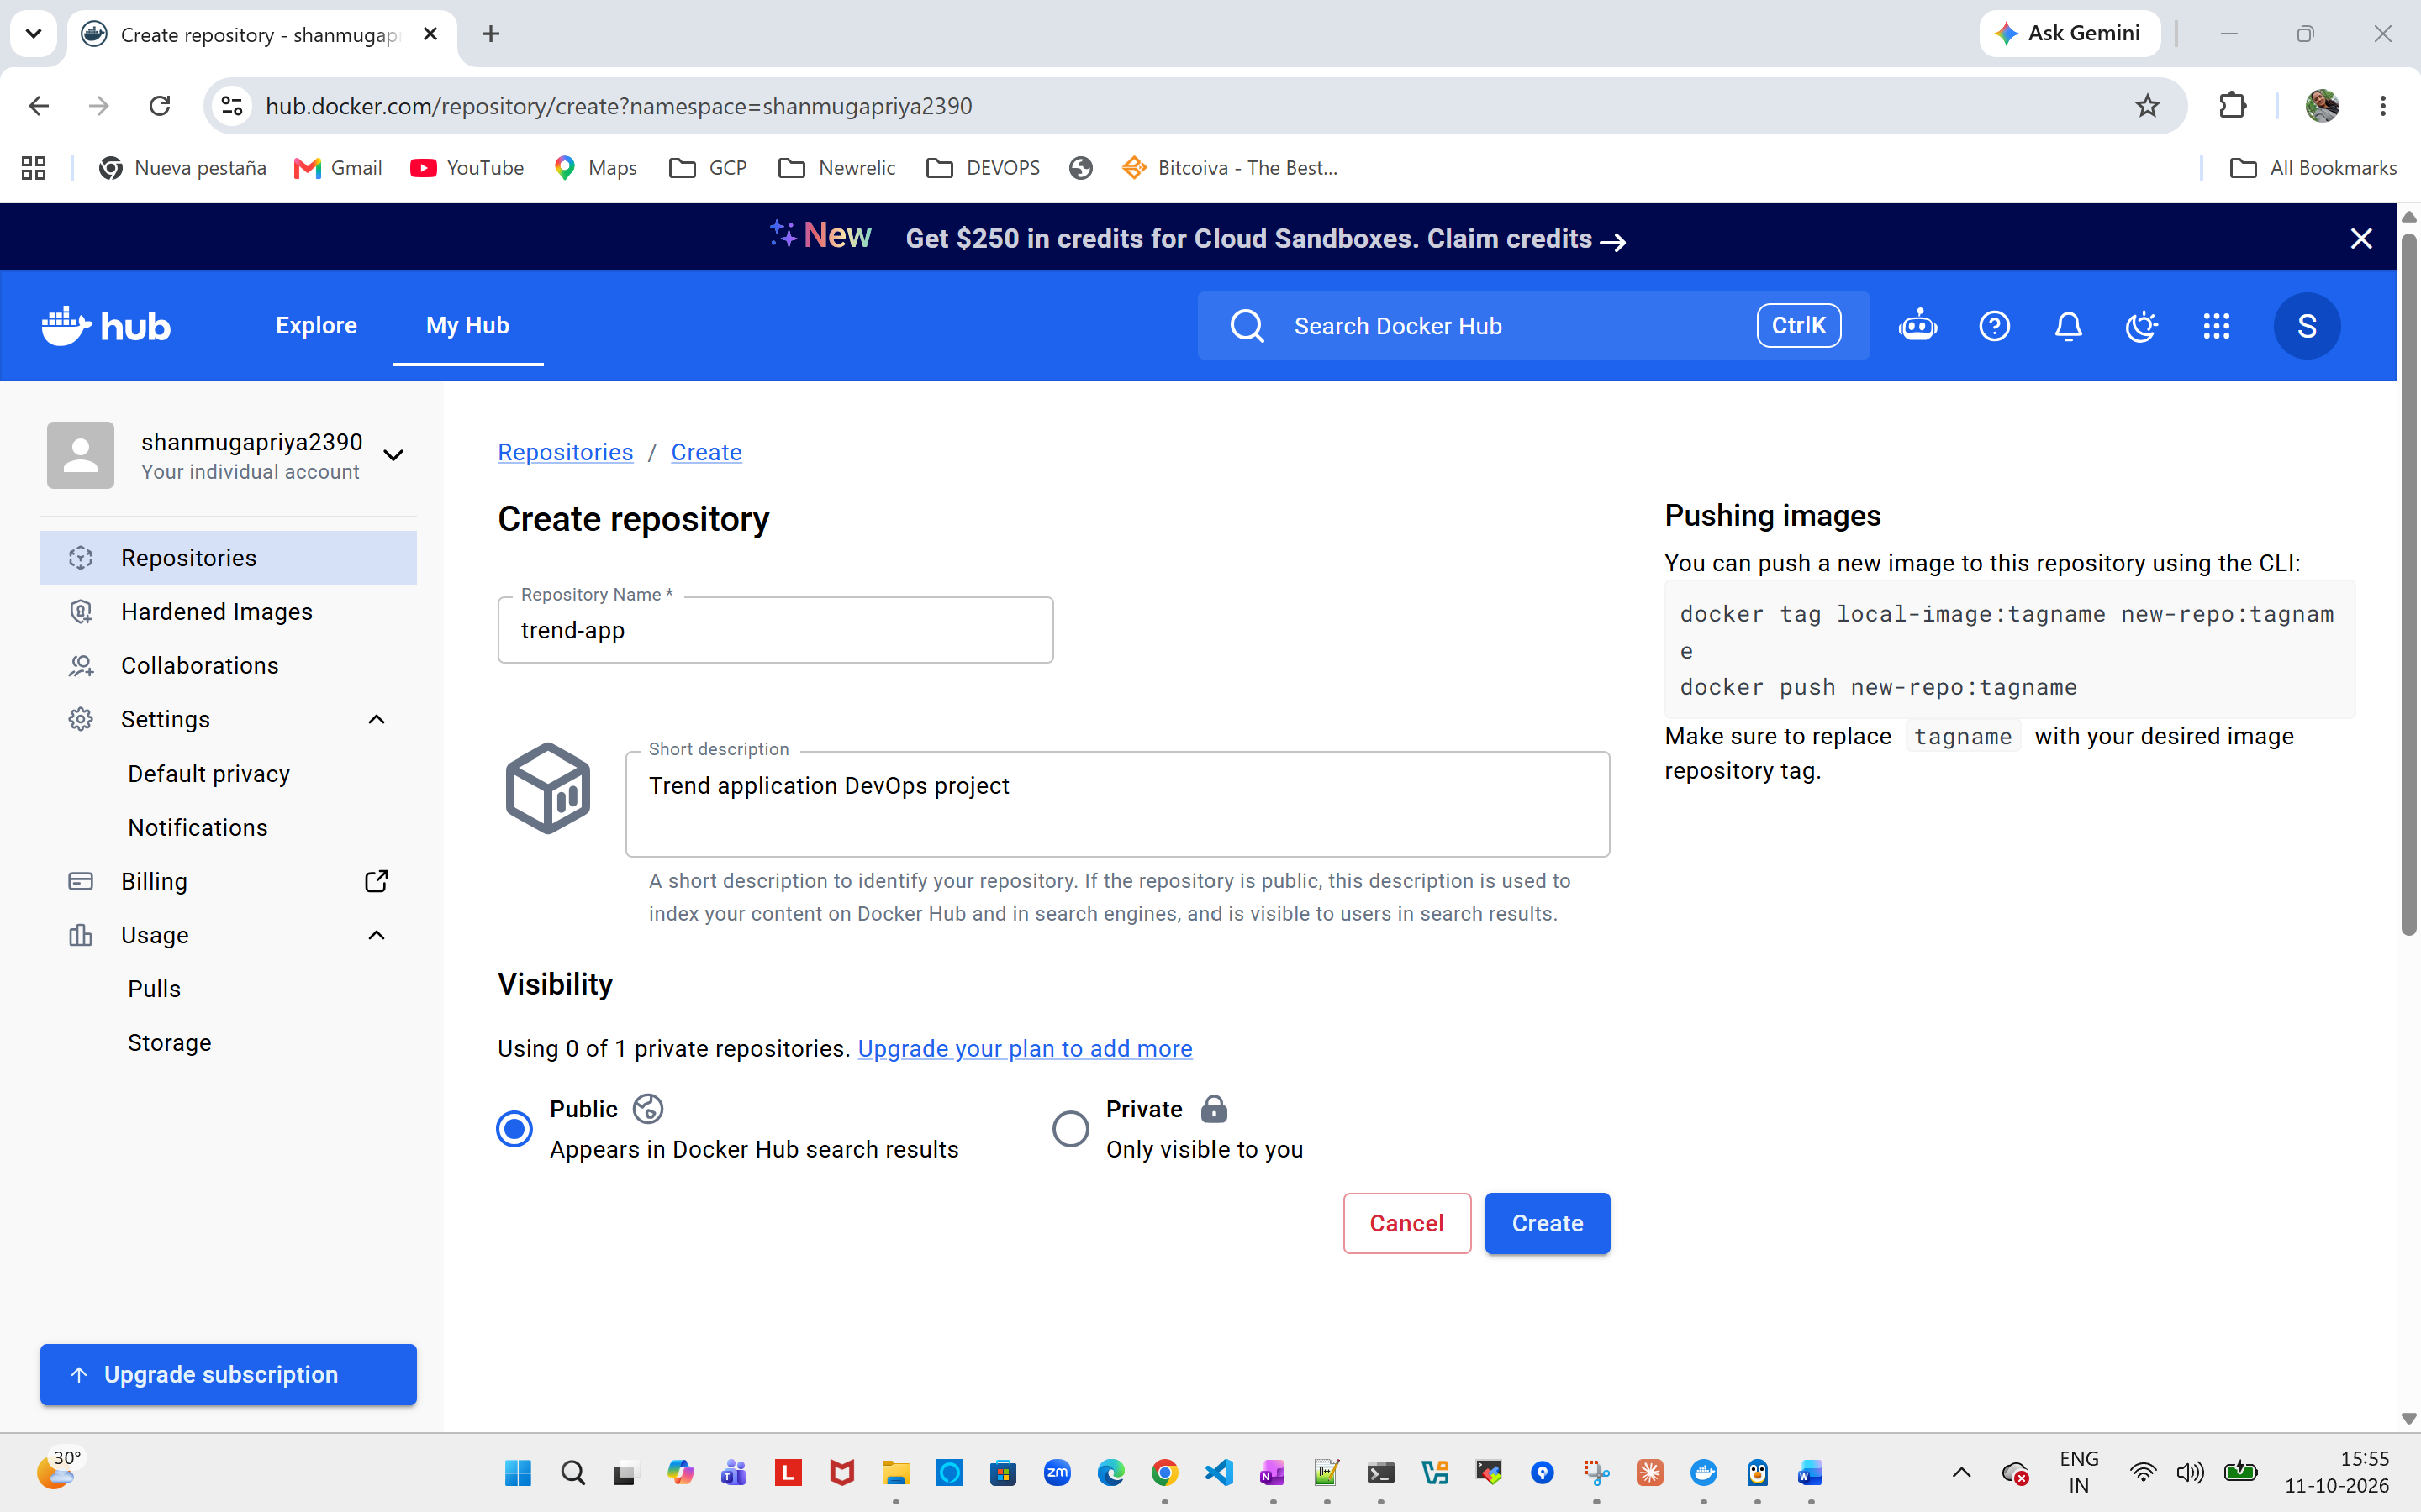

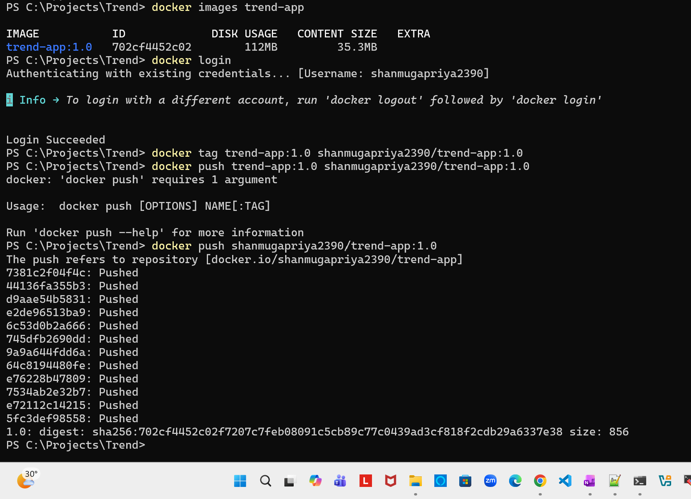

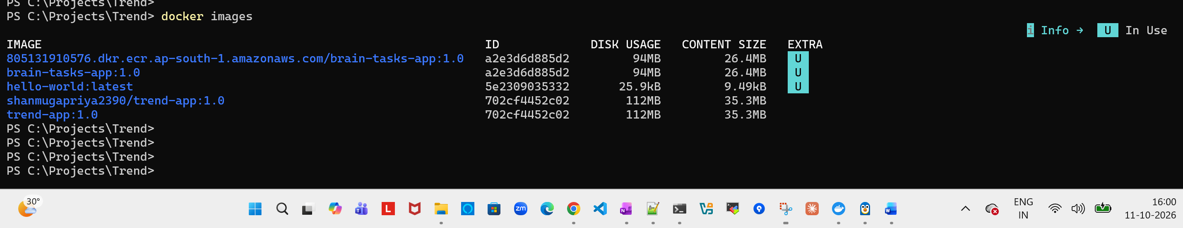

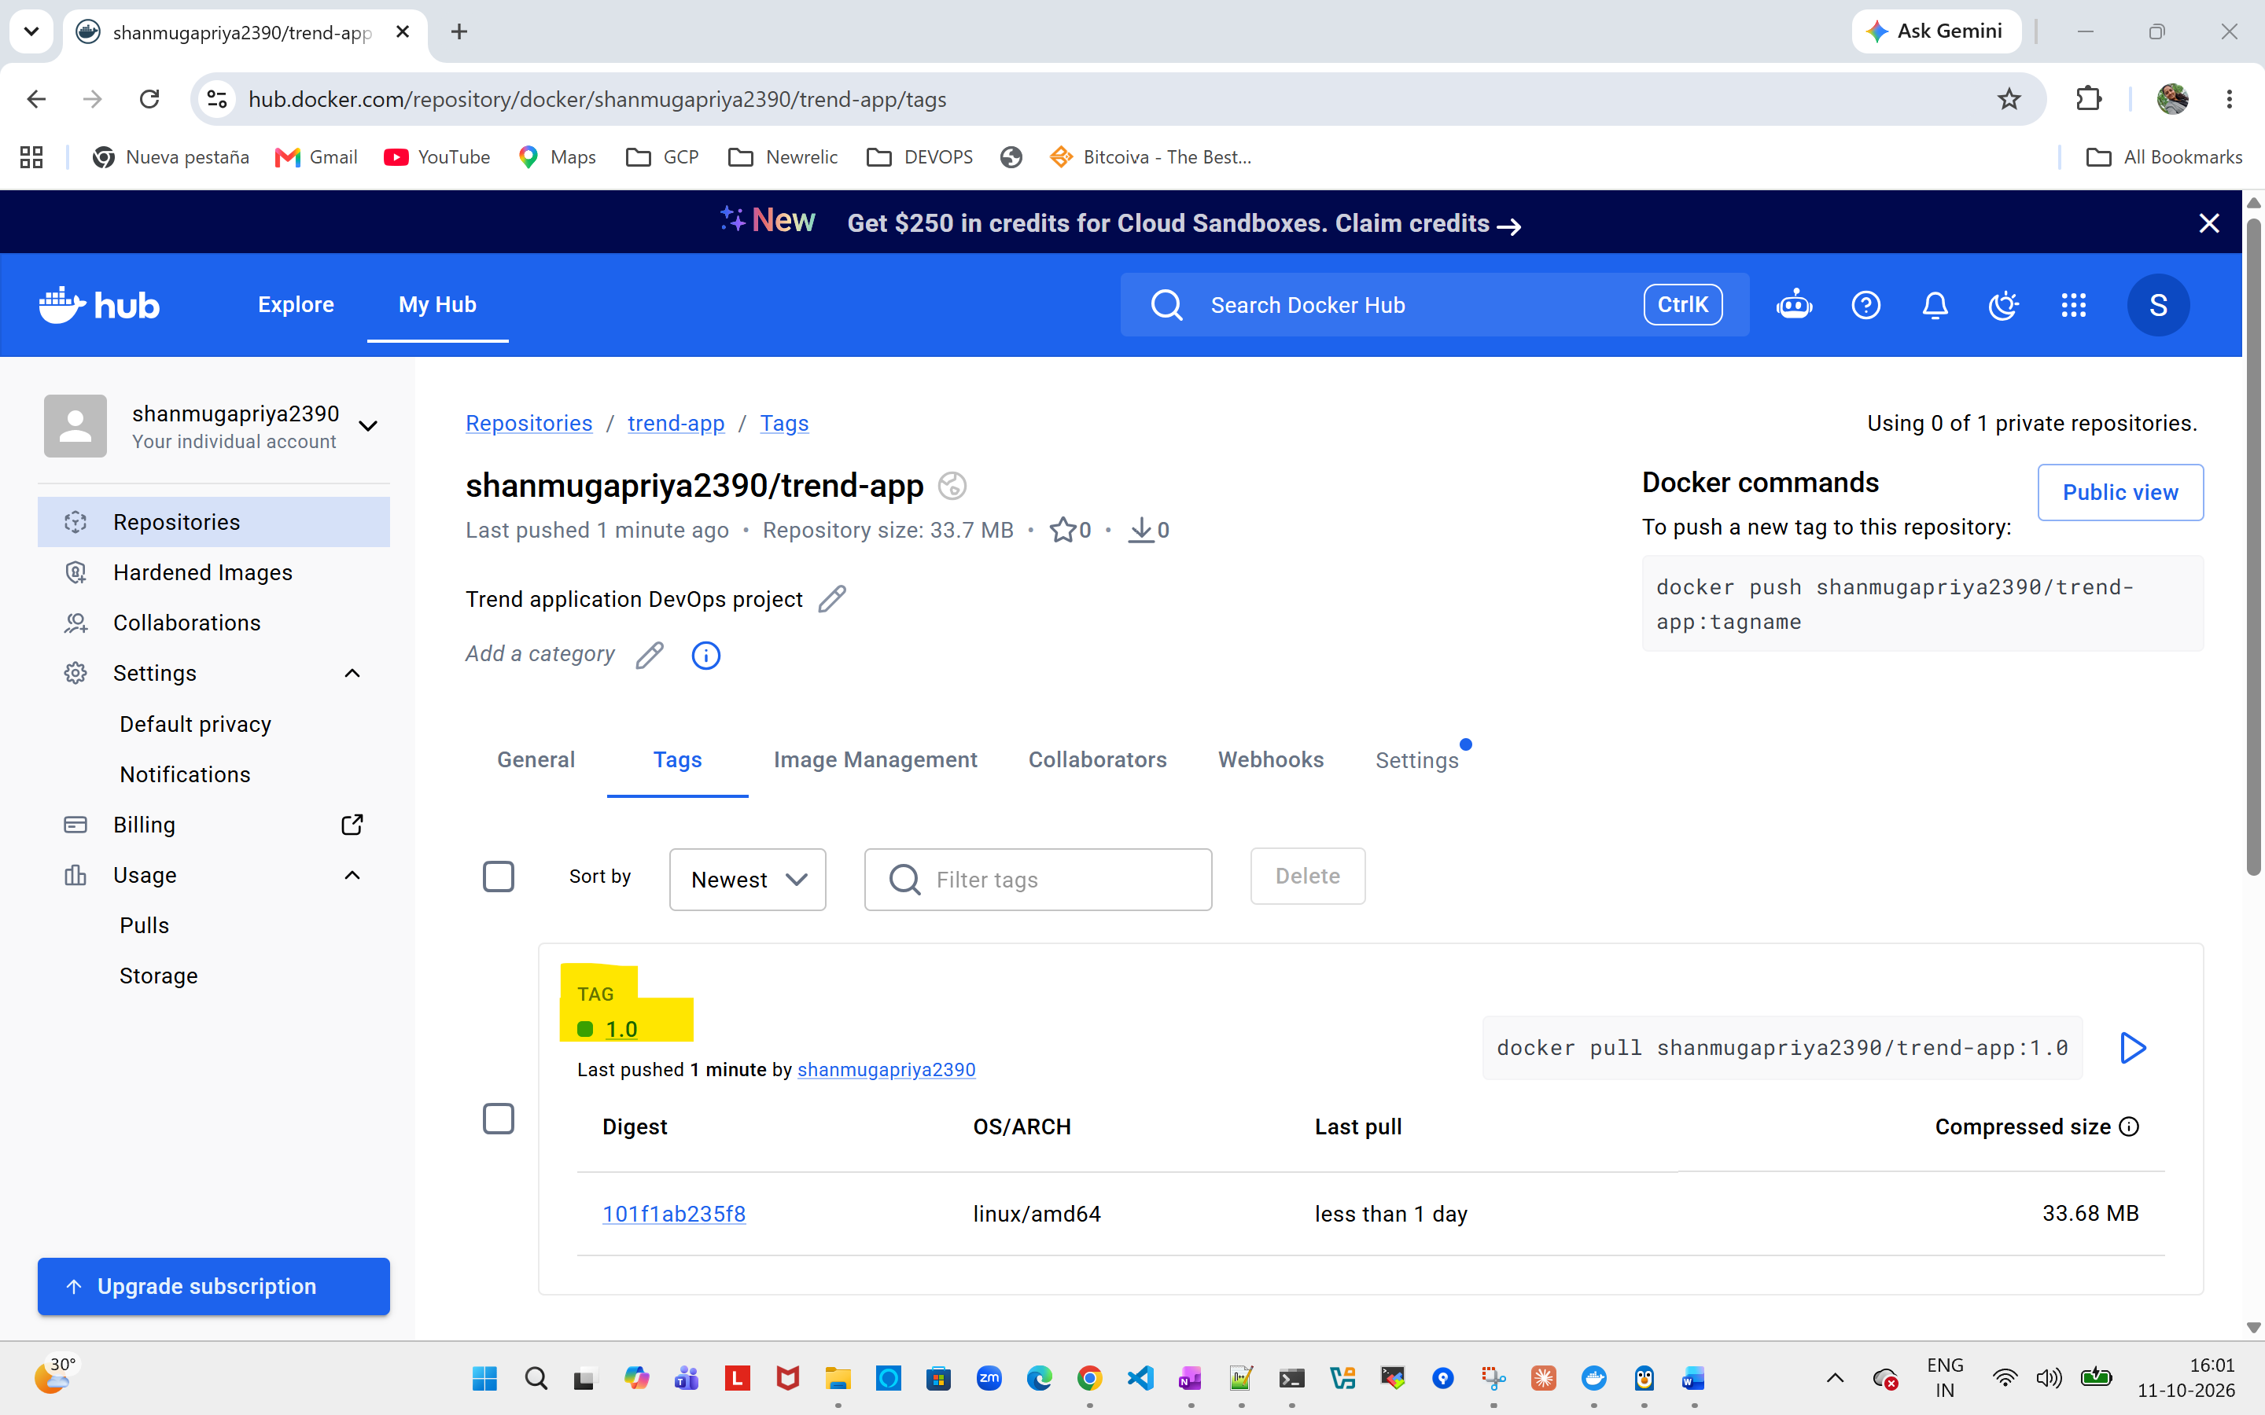

Terraform:
Main.tf
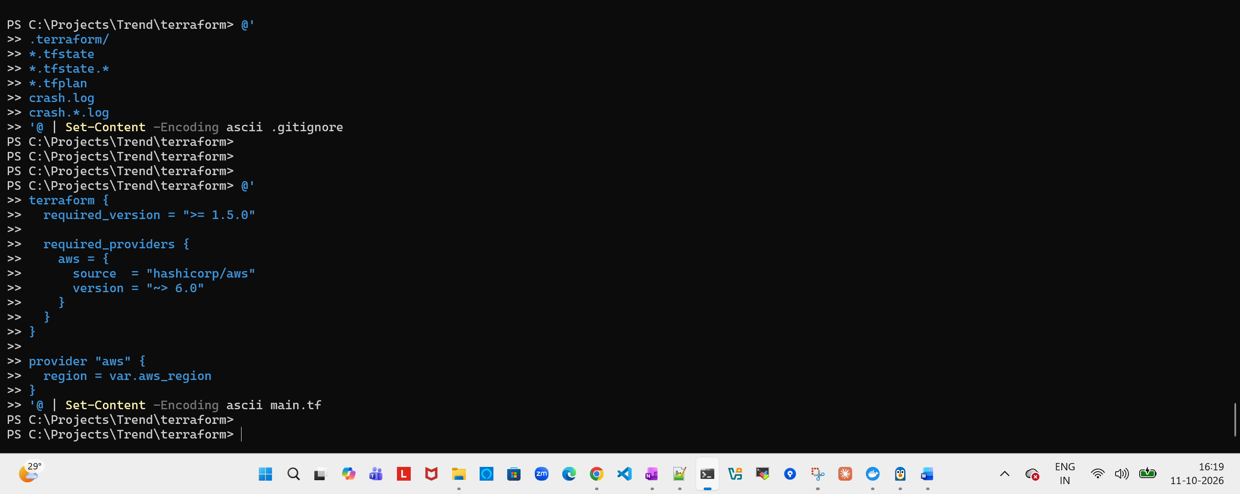
Variable.tf
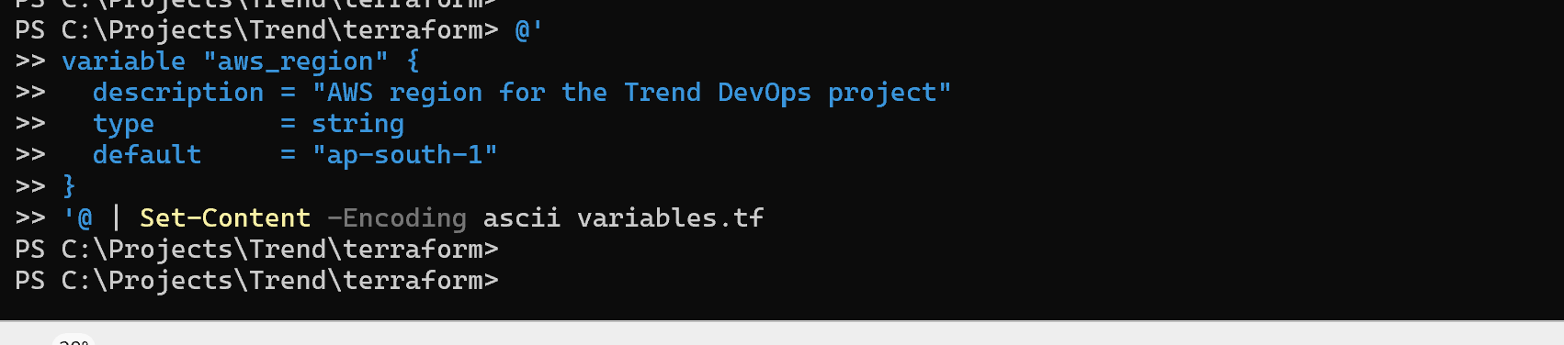

Outpuot.tf
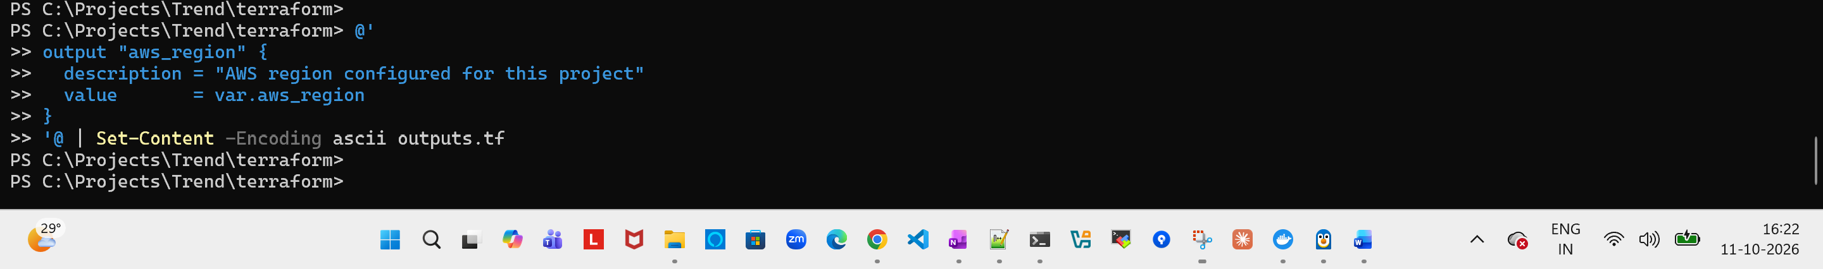

Terraform init
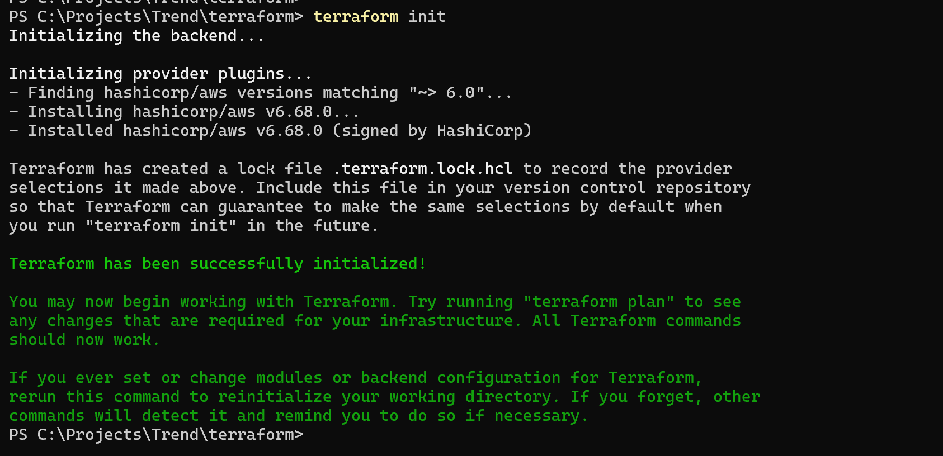
Add VPC and networking to main.tf

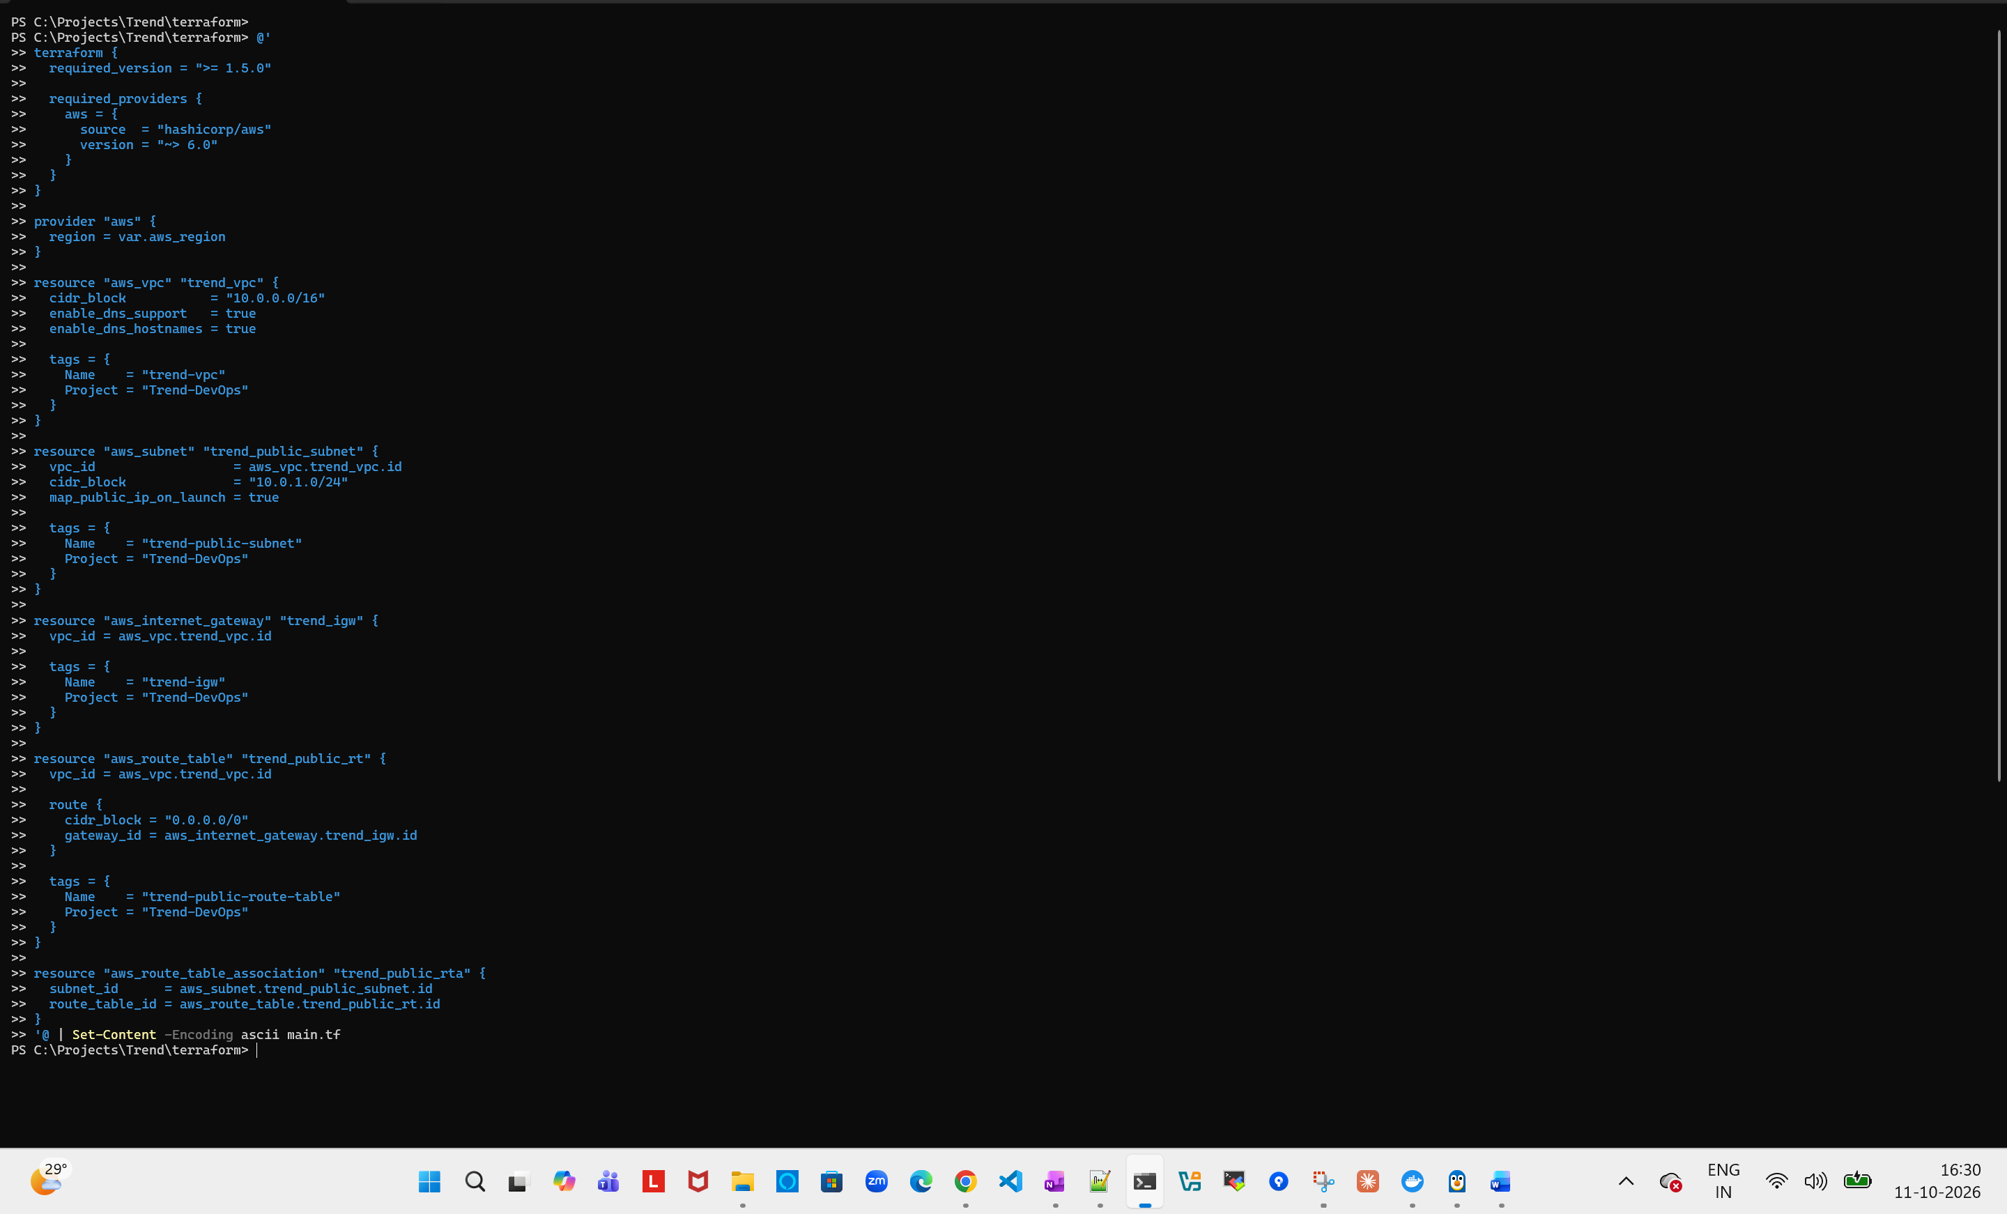
Terraform plan
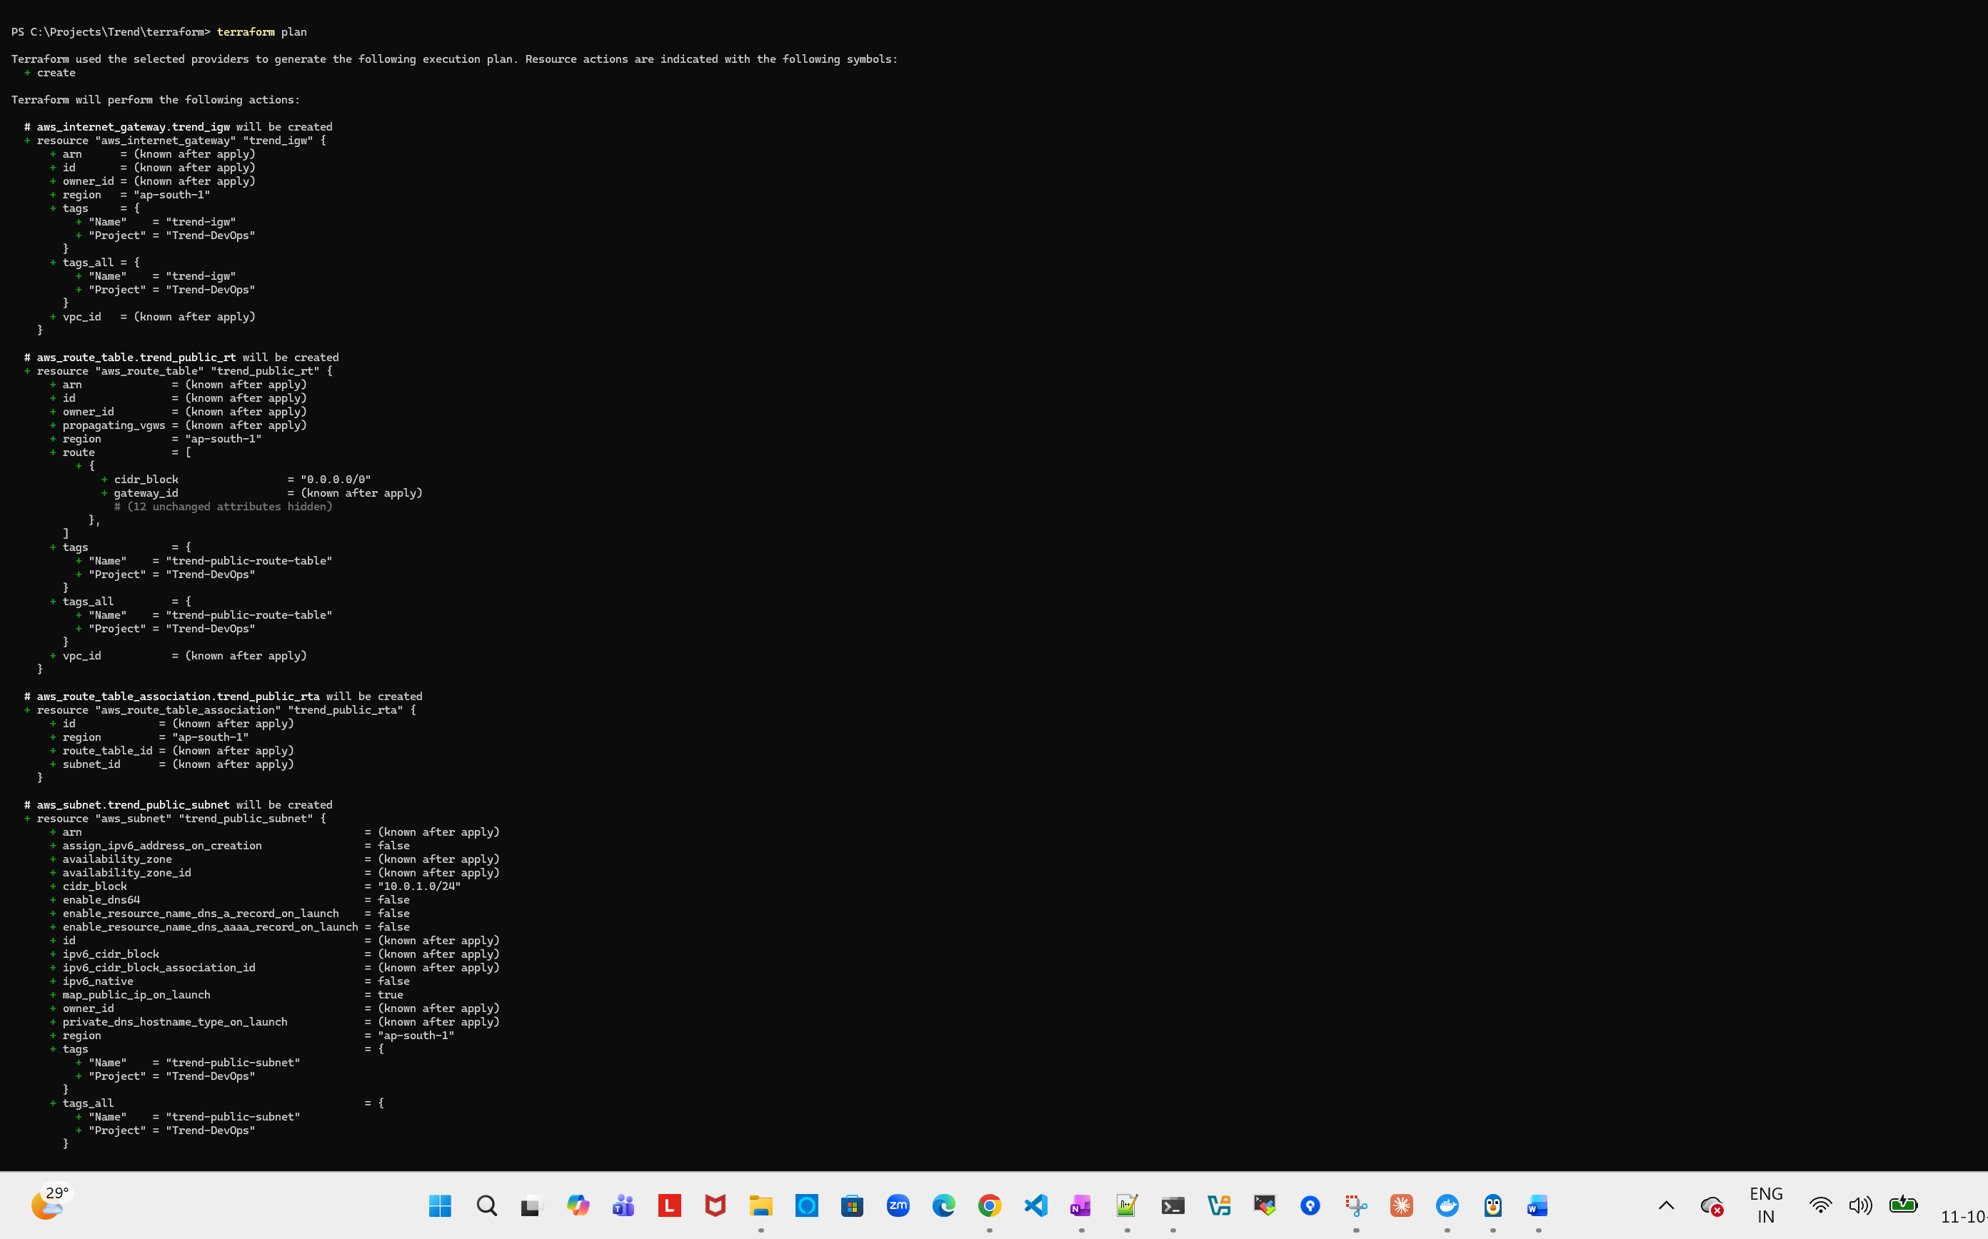
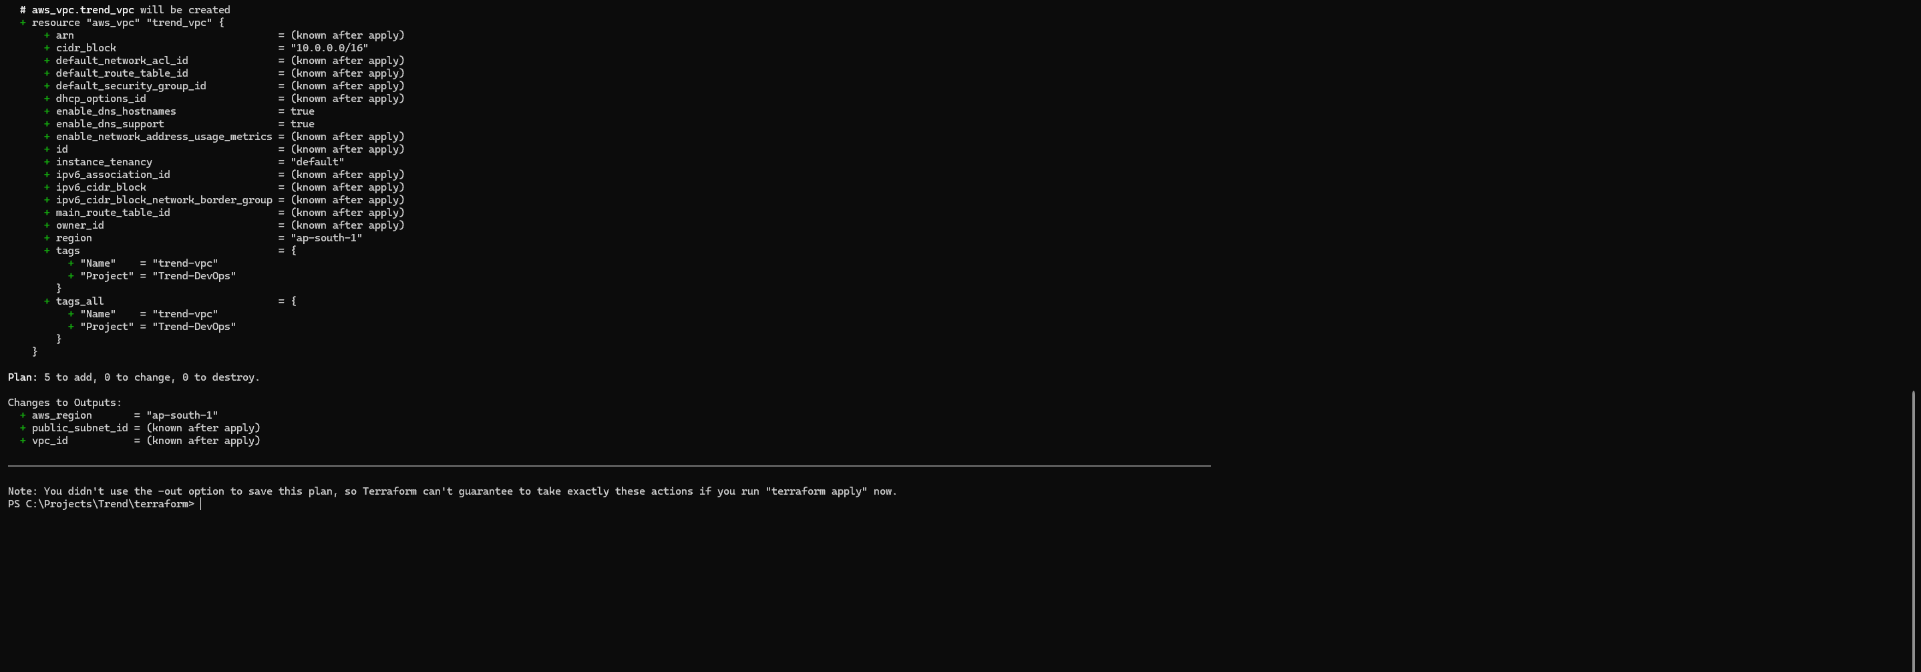

Terraform apply:
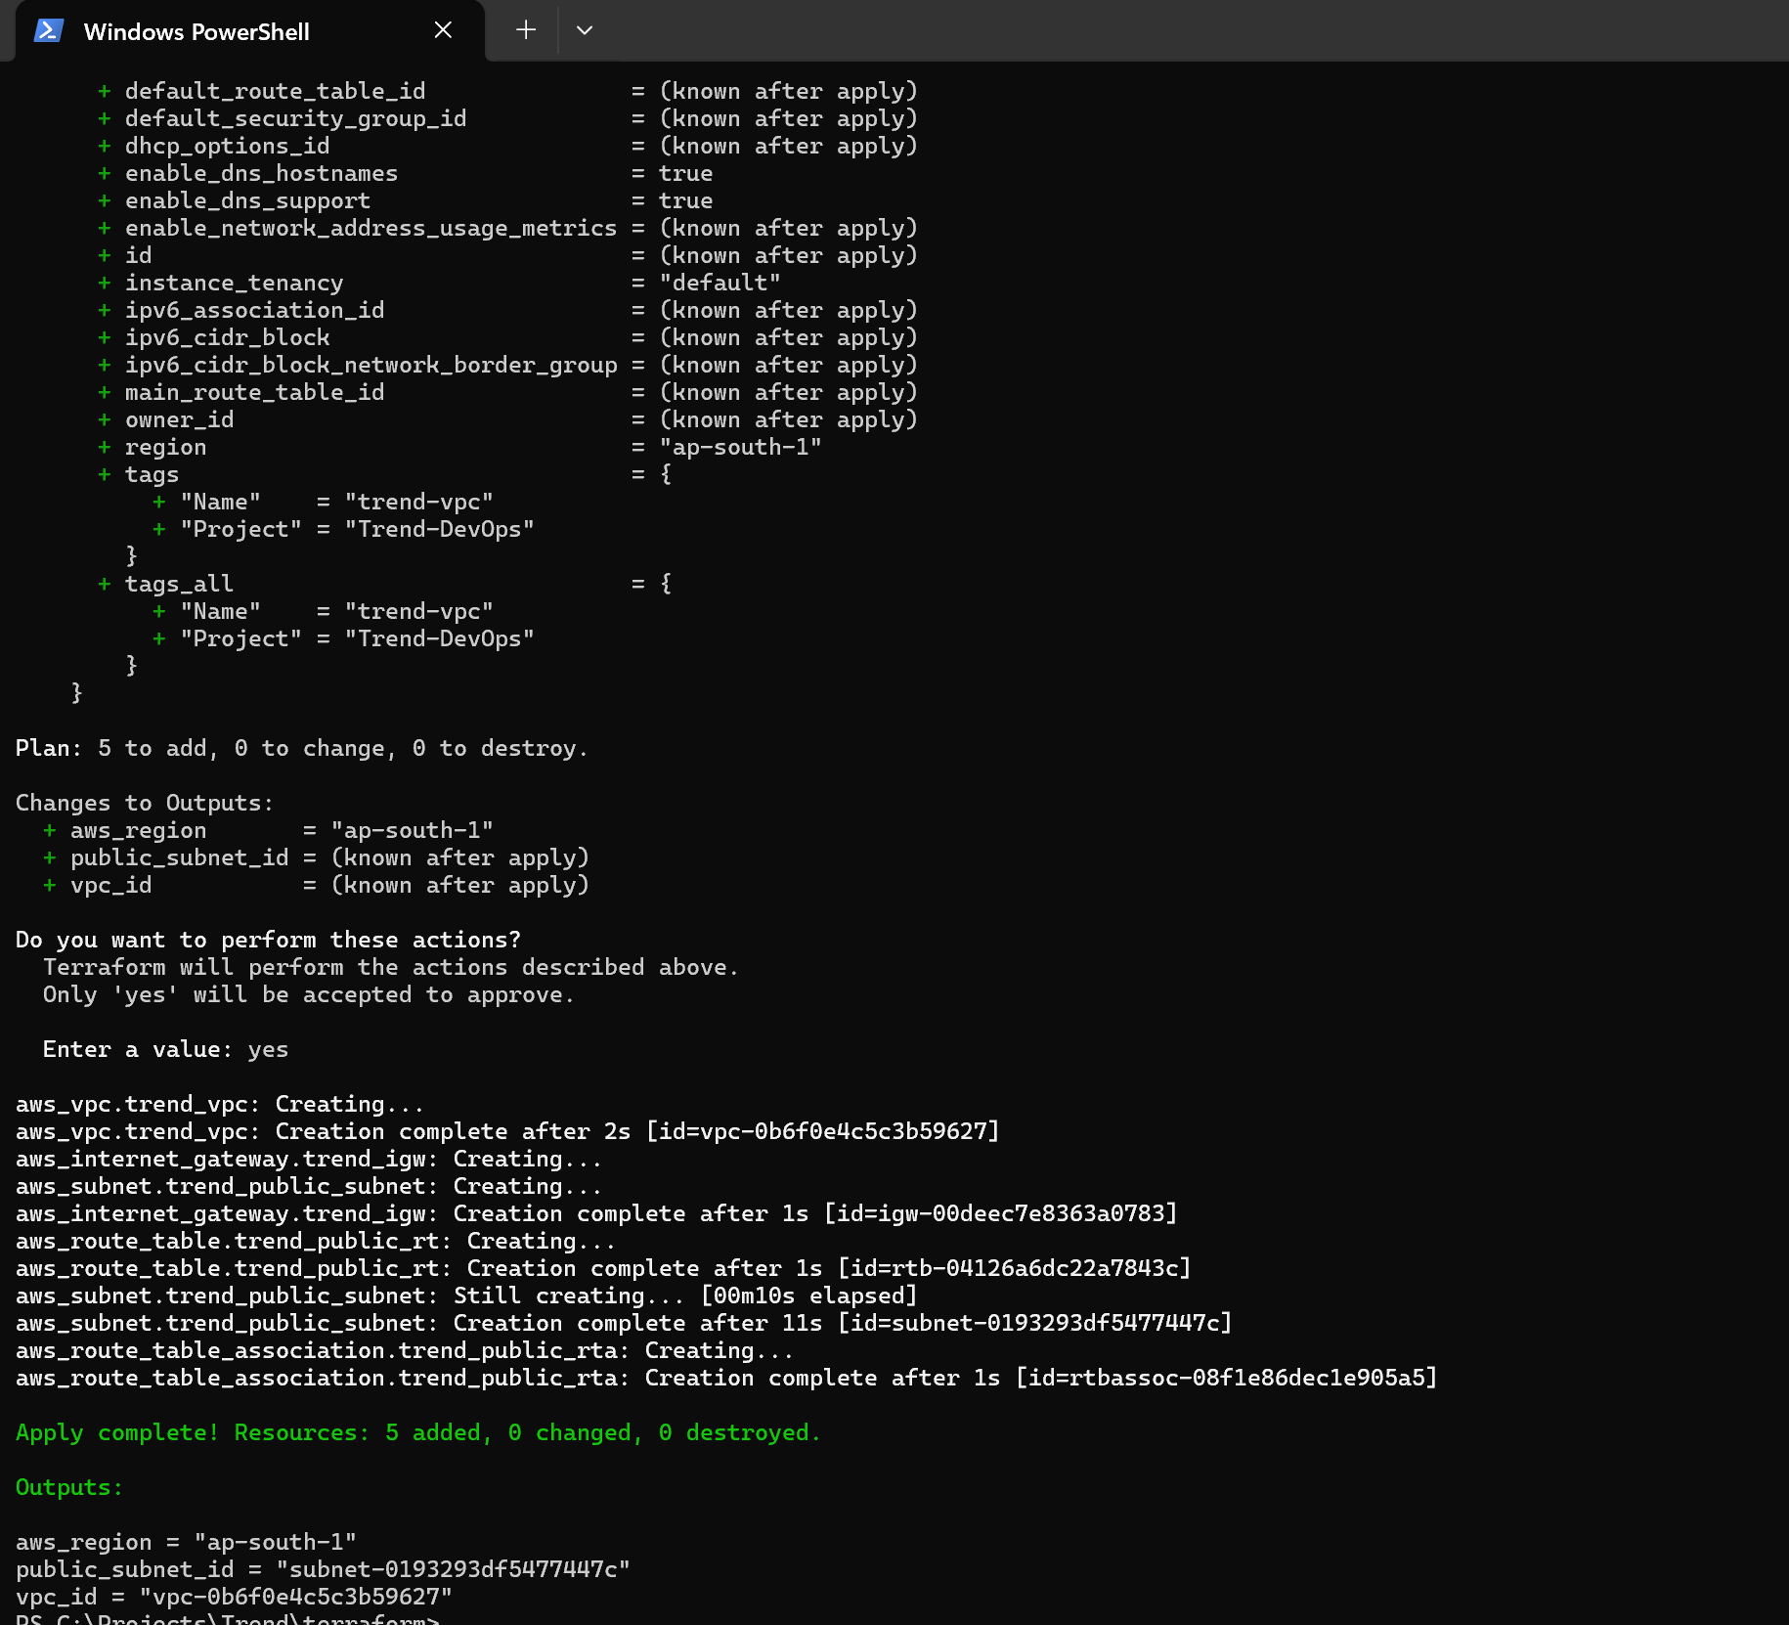

Create AWS resources:
PS C:\Projects\Trend\terraform> terraform apply
aws_vpc.trend_vpc: Refreshing state... [id=vpc-0b6f0e4c5c3b59627]
aws_internet_gateway.trend_igw: Refreshing state... [id=igw-00deec7e8363a0783]
aws_subnet.trend_public_subnet: Refreshing state... [id=subnet-0193293df5477447c]
aws_route_table.trend_public_rt: Refreshing state... [id=rtb-04126a6dc22a7843c]
aws_route_table_association.trend_public_rta: Refreshing state... [id=rtbassoc-08f1e86dec1e905a5]

Terraform used the selected providers to generate the following execution plan. Resource actions are indicated with the following symbols:
+ create

Terraform will perform the following actions:

# aws_iam_instance_profile.jenkins_profile will be created
+ resource "aws_iam_instance_profile" "jenkins_profile" {
+ arn = (known after apply)
+ create_date = (known after apply)
+ id = (known after apply)
+ name = "trend-jenkins-instance-profile"
+ name_prefix = (known after apply)
+ path = "/"
+ role = "trend-jenkins-ec2-role"
+ tags = {
+ "Project" = "Trend-DevOps"
}
+ tags_all = {
+ "Project" = "Trend-DevOps"
}
+ unique_id = (known after apply)
}

# aws_iam_role.jenkins_role will be created
+ resource "aws_iam_role" "jenkins_role" {
+ arn = (known after apply)
+ assume_role_policy = jsonencode(
{
+ Statement = [
+ {
+ Action = "sts:AssumeRole"
+ Effect = "Allow"
+ Principal = {
+ Service = "ec2.amazonaws.com"
}
},
]
+ Version = "2012-10-17"
}
)
+ create_date = (known after apply)
+ force_detach_policies = false
+ id = (known after apply)
+ managed_policy_arns = (known after apply)
+ max_session_duration = 3600
+ name = "trend-jenkins-ec2-role"
+ name_prefix = (known after apply)
+ path = "/"
+ tags = {
+ "Project" = "Trend-DevOps"
}
+ tags_all = {
+ "Project" = "Trend-DevOps"
}
+ unique_id = (known after apply)

+ inline_policy (known after apply)
}

# aws_iam_role_policy.jenkins_eks_describe will be created
+ resource "aws_iam_role_policy" "jenkins_eks_describe" {
+ id = (known after apply)
+ name = "trend-jenkins-eks-describe"
+ name_prefix = (known after apply)
+ policy = jsonencode(
{
+ Statement = [
+ {
+ Action = [
+ "eks:DescribeCluster",
]
+ Effect = "Allow"
+ Resource = "*"
},
]
+ Version = "2012-10-17"
}
)
+ role = (known after apply)
}

# aws_security_group.jenkins_sg will be created
+ resource "aws_security_group" "jenkins_sg" {
+ arn = (known after apply)
+ description = "Restricted access for Jenkins and SSH"
+ egress = [
+ {
+ cidr_blocks = [
+ "0.0.0.0/0",
]
+ description = "Outbound traffic for package downloads and deployments"
+ from_port = 0
+ ipv6_cidr_blocks = []
+ prefix_list_ids = []
+ protocol = "-1"
+ security_groups = []
+ self = false
+ to_port = 0
},
]
+ id = (known after apply)
+ ingress = [
+ {
+ cidr_blocks = [
+ "122.172.86.230/32",
]
+ description = "Jenkins web dashboard from administrator IP"
+ from_port = 8080
+ ipv6_cidr_blocks = []
+ prefix_list_ids = []
+ protocol = "tcp"
+ security_groups = []
+ self = false
+ to_port = 8080
},
+ {
+ cidr_blocks = [
+ "122.172.86.230/32",
]
+ description = "SSH from administrator IP"
+ from_port = 22
+ ipv6_cidr_blocks = []
+ prefix_list_ids = []
+ protocol = "tcp"
+ security_groups = []
+ self = false
+ to_port = 22
},
]
+ name = "trend-jenkins-sg"
+ name_prefix = (known after apply)
+ owner_id = (known after apply)
+ region = "ap-south-1"
+ revoke_rules_on_delete = false
+ tags = {
+ "Name" = "trend-jenkins-sg"
+ "Project" = "Trend-DevOps"
}
+ tags_all = {
+ "Name" = "trend-jenkins-sg"
+ "Project" = "Trend-DevOps"
}
+ vpc_id = "vpc-0b6f0e4c5c3b59627"
}

Plan: 4 to add, 0 to change, 0 to destroy.

Changes to Outputs:
+ jenkins_role_arn = (known after apply)
+ jenkins_security_group_id = (known after apply)

Do you want to perform these actions?
Terraform will perform the actions described above.
Only 'yes' will be accepted to approve.

Enter a value: yes

aws_iam_role.jenkins_role: Creating...
aws_security_group.jenkins_sg: Creating...
aws_iam_role.jenkins_role: Creation complete after 2s [id=trend-jenkins-ec2-role]
aws_iam_instance_profile.jenkins_profile: Creating...
aws_iam_role_policy.jenkins_eks_describe: Creating...
aws_security_group.jenkins_sg: Creation complete after 2s [id=sg-040904510214d6fd4]
aws_iam_role_policy.jenkins_eks_describe: Creation complete after 1s [id=trend-jenkins-ec2-role:trend-jenkins-eks-describe]
aws_iam_instance_profile.jenkins_profile: Creation complete after 8s [id=trend-jenkins-instance-profile]

Apply complete! Resources: 4 added, 0 changed, 0 destroyed.

Outputs:

aws_region = "ap-south-1"
jenkins_role_arn = "arn:aws:iam::049427513291:role/trend-jenkins-ec2-role"
jenkins_security_group_id = "sg-040904510214d6fd4"
public_subnet_id = "subnet-0193293df5477447c"
vpc_id = "vpc-0b6f0e4c5c3b59627"
PS C:\Projects\Trend\terraform>

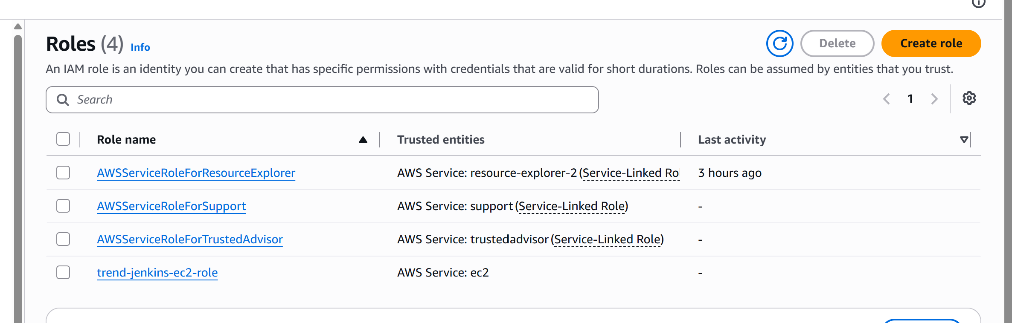

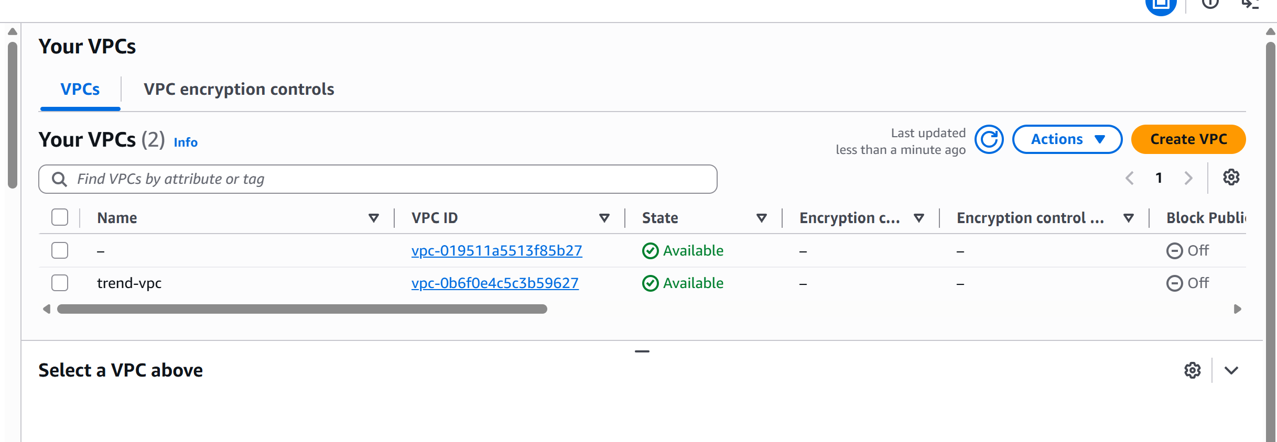
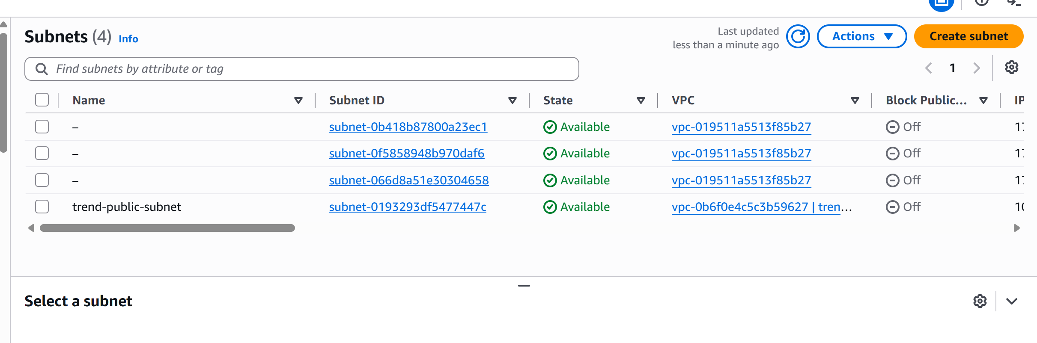
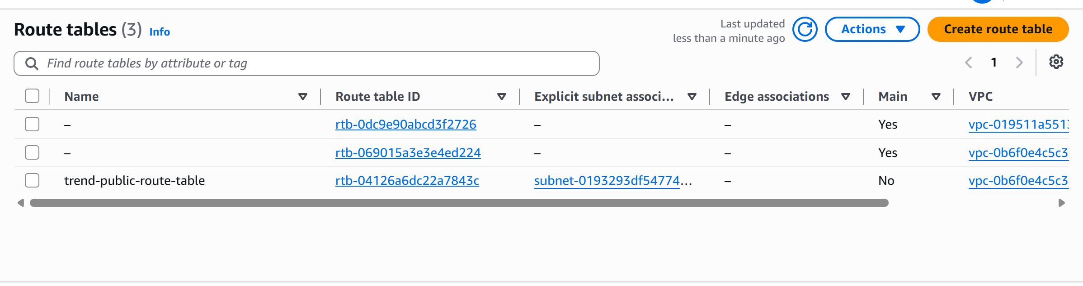

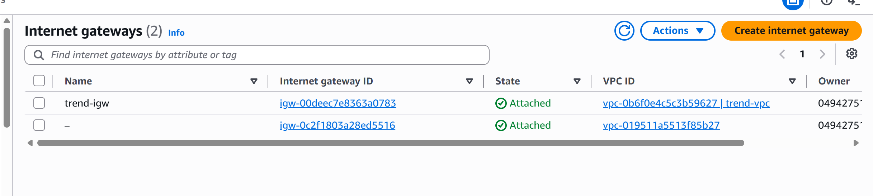
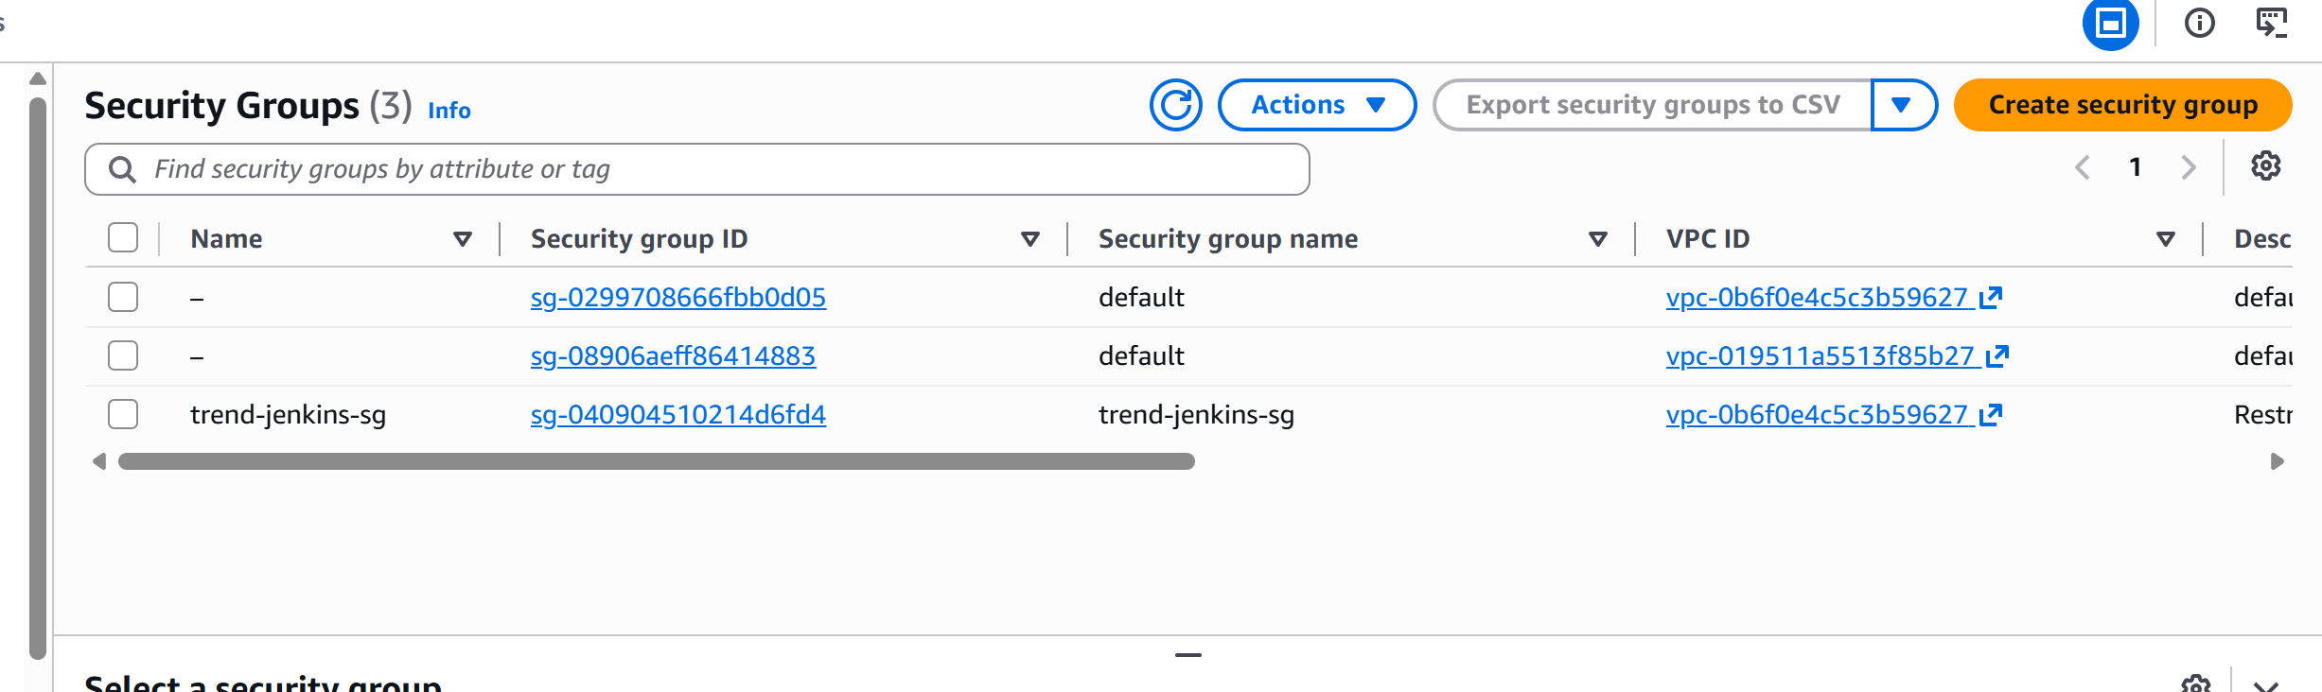

Add the Jenkins EC2 instance to Terraform
PS C:\Projects\Trend\terraform> terraform apply
data.aws_ssm_parameter.ubuntu_ami: Reading...
aws_vpc.trend_vpc: Refreshing state... [id=vpc-0b6f0e4c5c3b59627]
aws_iam_role.jenkins_role: Refreshing state... [id=trend-jenkins-ec2-role]
data.aws_ssm_parameter.ubuntu_ami: Read complete after 0s [id=/aws/service/canonical/ubuntu/server/noble/stable/current/amd64/hvm/ebs-gp3/ami-id]
aws_internet_gateway.trend_igw: Refreshing state... [id=igw-00deec7e8363a0783]
aws_subnet.trend_public_subnet: Refreshing state... [id=subnet-0193293df5477447c]
aws_security_group.jenkins_sg: Refreshing state... [id=sg-040904510214d6fd4]
aws_route_table.trend_public_rt: Refreshing state... [id=rtb-04126a6dc22a7843c]
aws_route_table_association.trend_public_rta: Refreshing state... [id=rtbassoc-08f1e86dec1e905a5]
aws_iam_role_policy.jenkins_eks_describe: Refreshing state... [id=trend-jenkins-ec2-role:trend-jenkins-eks-describe]
aws_iam_instance_profile.jenkins_profile: Refreshing state... [id=trend-jenkins-instance-profile]

Terraform used the selected providers to generate the following execution plan. Resource actions are indicated with the following symbols:
+ create

Terraform will perform the following actions:

# aws_instance.jenkins_server will be created
+ resource "aws_instance" "jenkins_server" {
+ ami = (sensitive value)
+ arn = (known after apply)
+ associate_public_ip_address = true
+ availability_zone = (known after apply)
+ disable_api_stop = (known after apply)
+ disable_api_termination = (known after apply)
+ ebs_optimized = (known after apply)
+ enable_primary_ipv6 = (known after apply)
+ force_destroy = false
+ get_password_data = false
+ host_id = (known after apply)
+ host_resource_group_arn = (known after apply)
+ iam_instance_profile = "trend-jenkins-instance-profile"
+ id = (known after apply)
+ instance_initiated_shutdown_behavior = (known after apply)
+ instance_lifecycle = (known after apply)
+ instance_state = (known after apply)
+ instance_type = "t3.small"
+ ipv6_address_count = (known after apply)
+ ipv6_addresses = (known after apply)
+ key_name = "trend-jenkins-key"
+ monitoring = (known after apply)
+ outpost_arn = (known after apply)
+ password_data = (known after apply)
+ placement_group = (known after apply)
+ placement_group_id = (known after apply)
+ placement_partition_number = (known after apply)
+ primary_network_interface_id = (known after apply)
+ private_dns = (known after apply)
+ private_ip = (known after apply)
+ public_dns = (known after apply)
+ public_ip = (known after apply)
+ region = "ap-south-1"
+ secondary_private_ips = (known after apply)
+ security_groups = (known after apply)
+ source_dest_check = true
+ spot_instance_request_id = (known after apply)
+ subnet_id = "subnet-0193293df5477447c"
+ tags = {
+ "Name" = "trend-jenkins-server"
+ "Project" = "Trend-DevOps"
}
+ tags_all = {
+ "Name" = "trend-jenkins-server"
+ "Project" = "Trend-DevOps"
}
+ tenancy = (known after apply)
+ user_data_base64 = (known after apply)
+ user_data_replace_on_change = false
+ vpc_security_group_ids = [
+ "sg-040904510214d6fd4",
]

+ capacity_reservation_specification (known after apply)

+ cpu_options (known after apply)

+ ebs_block_device (known after apply)

+ enclave_options (known after apply)

+ ephemeral_block_device (known after apply)

+ instance_market_options (known after apply)

+ maintenance_options (known after apply)

+ metadata_options {
+ http_endpoint = "enabled"
+ http_protocol_ipv6 = "disabled"
+ http_put_response_hop_limit = (known after apply)
+ http_tokens = "required"
+ instance_metadata_tags = (known after apply)
}

+ network_interface (known after apply)

+ primary_network_interface (known after apply)

+ private_dns_name_options (known after apply)

+ root_block_device {
+ delete_on_termination = true
+ device_name = (known after apply)
+ encrypted = true
+ iops = (known after apply)
+ kms_key_id = (known after apply)
+ tags_all = (known after apply)
+ throughput = (known after apply)
+ volume_id = (known after apply)
+ volume_size = 20
+ volume_type = "gp3"
}

+ secondary_network_interface (known after apply)
}

Plan: 1 to add, 0 to change, 0 to destroy.

Changes to Outputs:
+ jenkins_instance_id = (known after apply)
+ jenkins_public_ip = (known after apply)

Do you want to perform these actions?
Terraform will perform the actions described above.
Only 'yes' will be accepted to approve.

Enter a value: yes

aws_instance.jenkins_server: Creating...
aws_instance.jenkins_server: Still creating... [00m10s elapsed]
aws_instance.jenkins_server: Creation complete after 13s [id=i-013958861f38dd402]

Apply complete! Resources: 1 added, 0 changed, 0 destroyed.

Outputs:

aws_region = "ap-south-1"
jenkins_instance_id = "i-013958861f38dd402"
jenkins_public_ip = "16.4.77.29"
jenkins_role_arn = "arn:aws:iam::049427513291:role/trend-jenkins-ec2-role"
jenkins_security_group_id = "sg-040904510214d6fd4"
public_subnet_id = "subnet-0193293df5477447c"
vpc_id = "vpc-0b6f0e4c5c3b59627"
PS C:\Projects\Trend\terraform>

PS C:\Projects\Trend\terraform> terraform output
aws_region = "ap-south-1"
jenkins_instance_id = "i-013958861f38dd402"
jenkins_public_ip = "16.4.77.29"
jenkins_role_arn = "arn:aws:iam::049427513291:role/trend-jenkins-ec2-role"
jenkins_security_group_id = "sg-040904510214d6fd4"
public_subnet_id = "subnet-0193293df5477447c"
vpc_id = "vpc-0b6f0e4c5c3b59627"
PS C:\Projects\Trend\terraform>

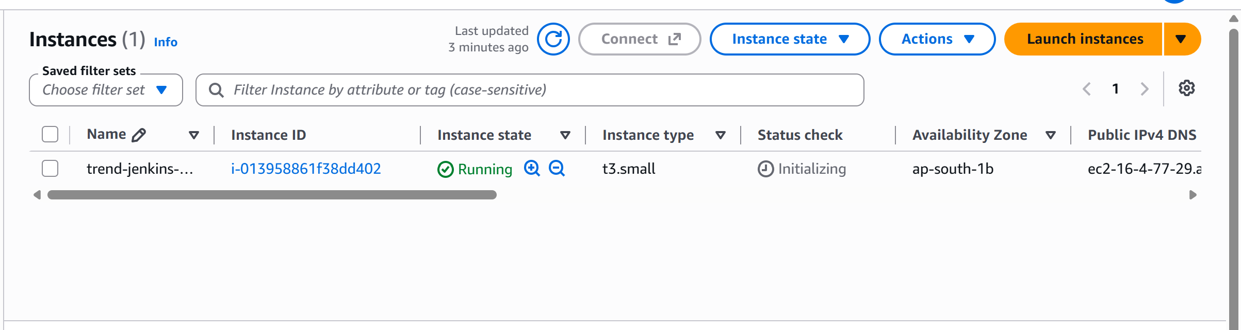

Jenkins Configurstion:

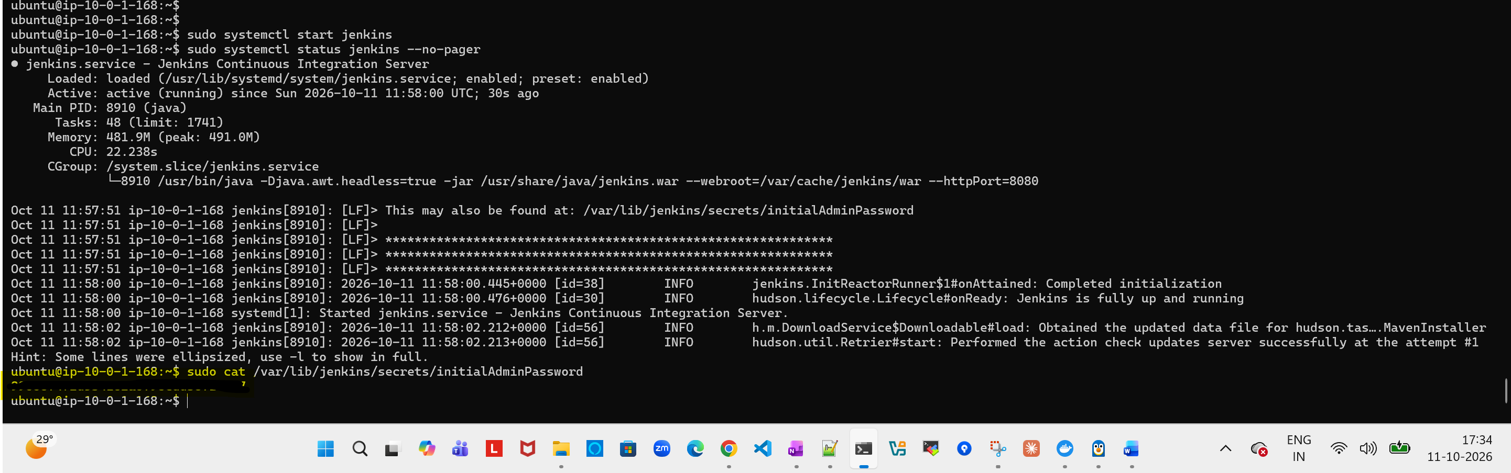

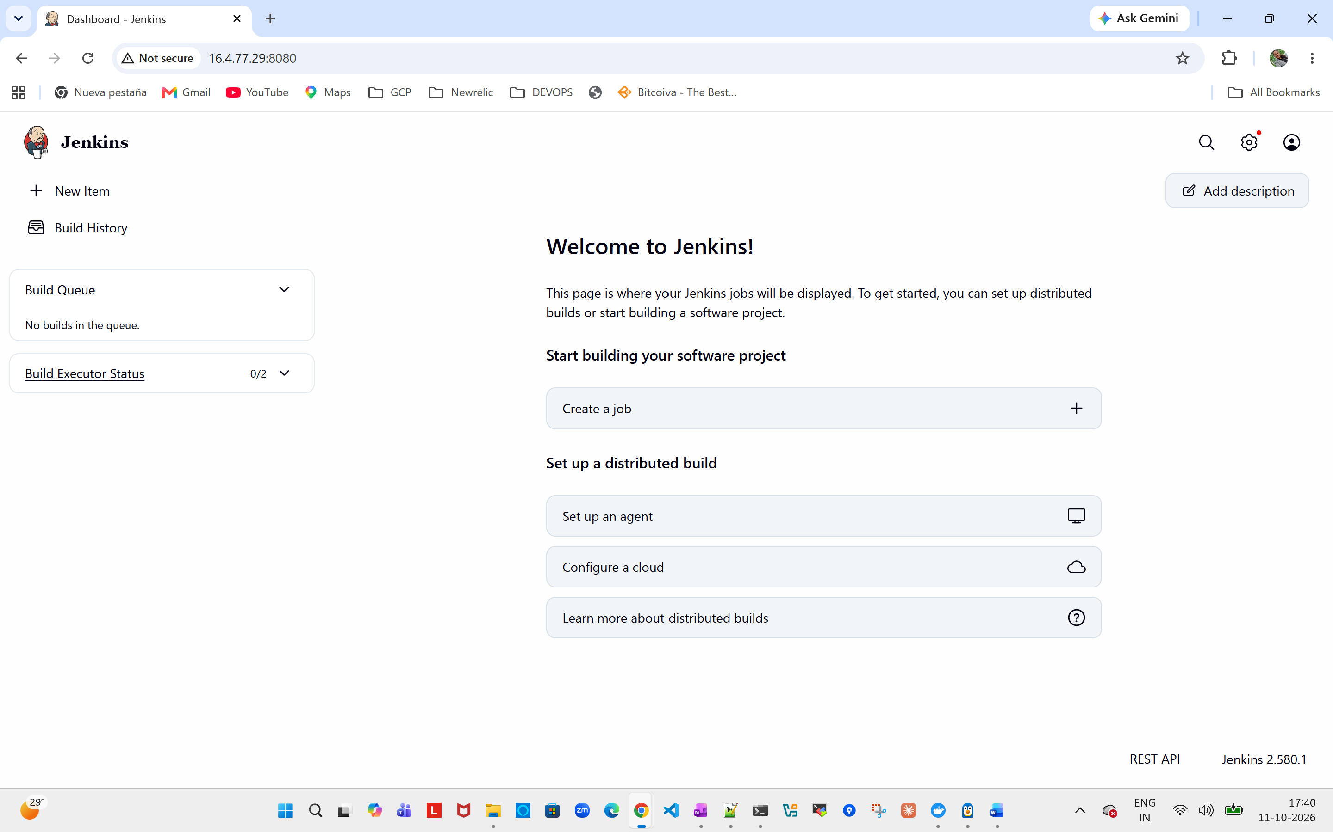
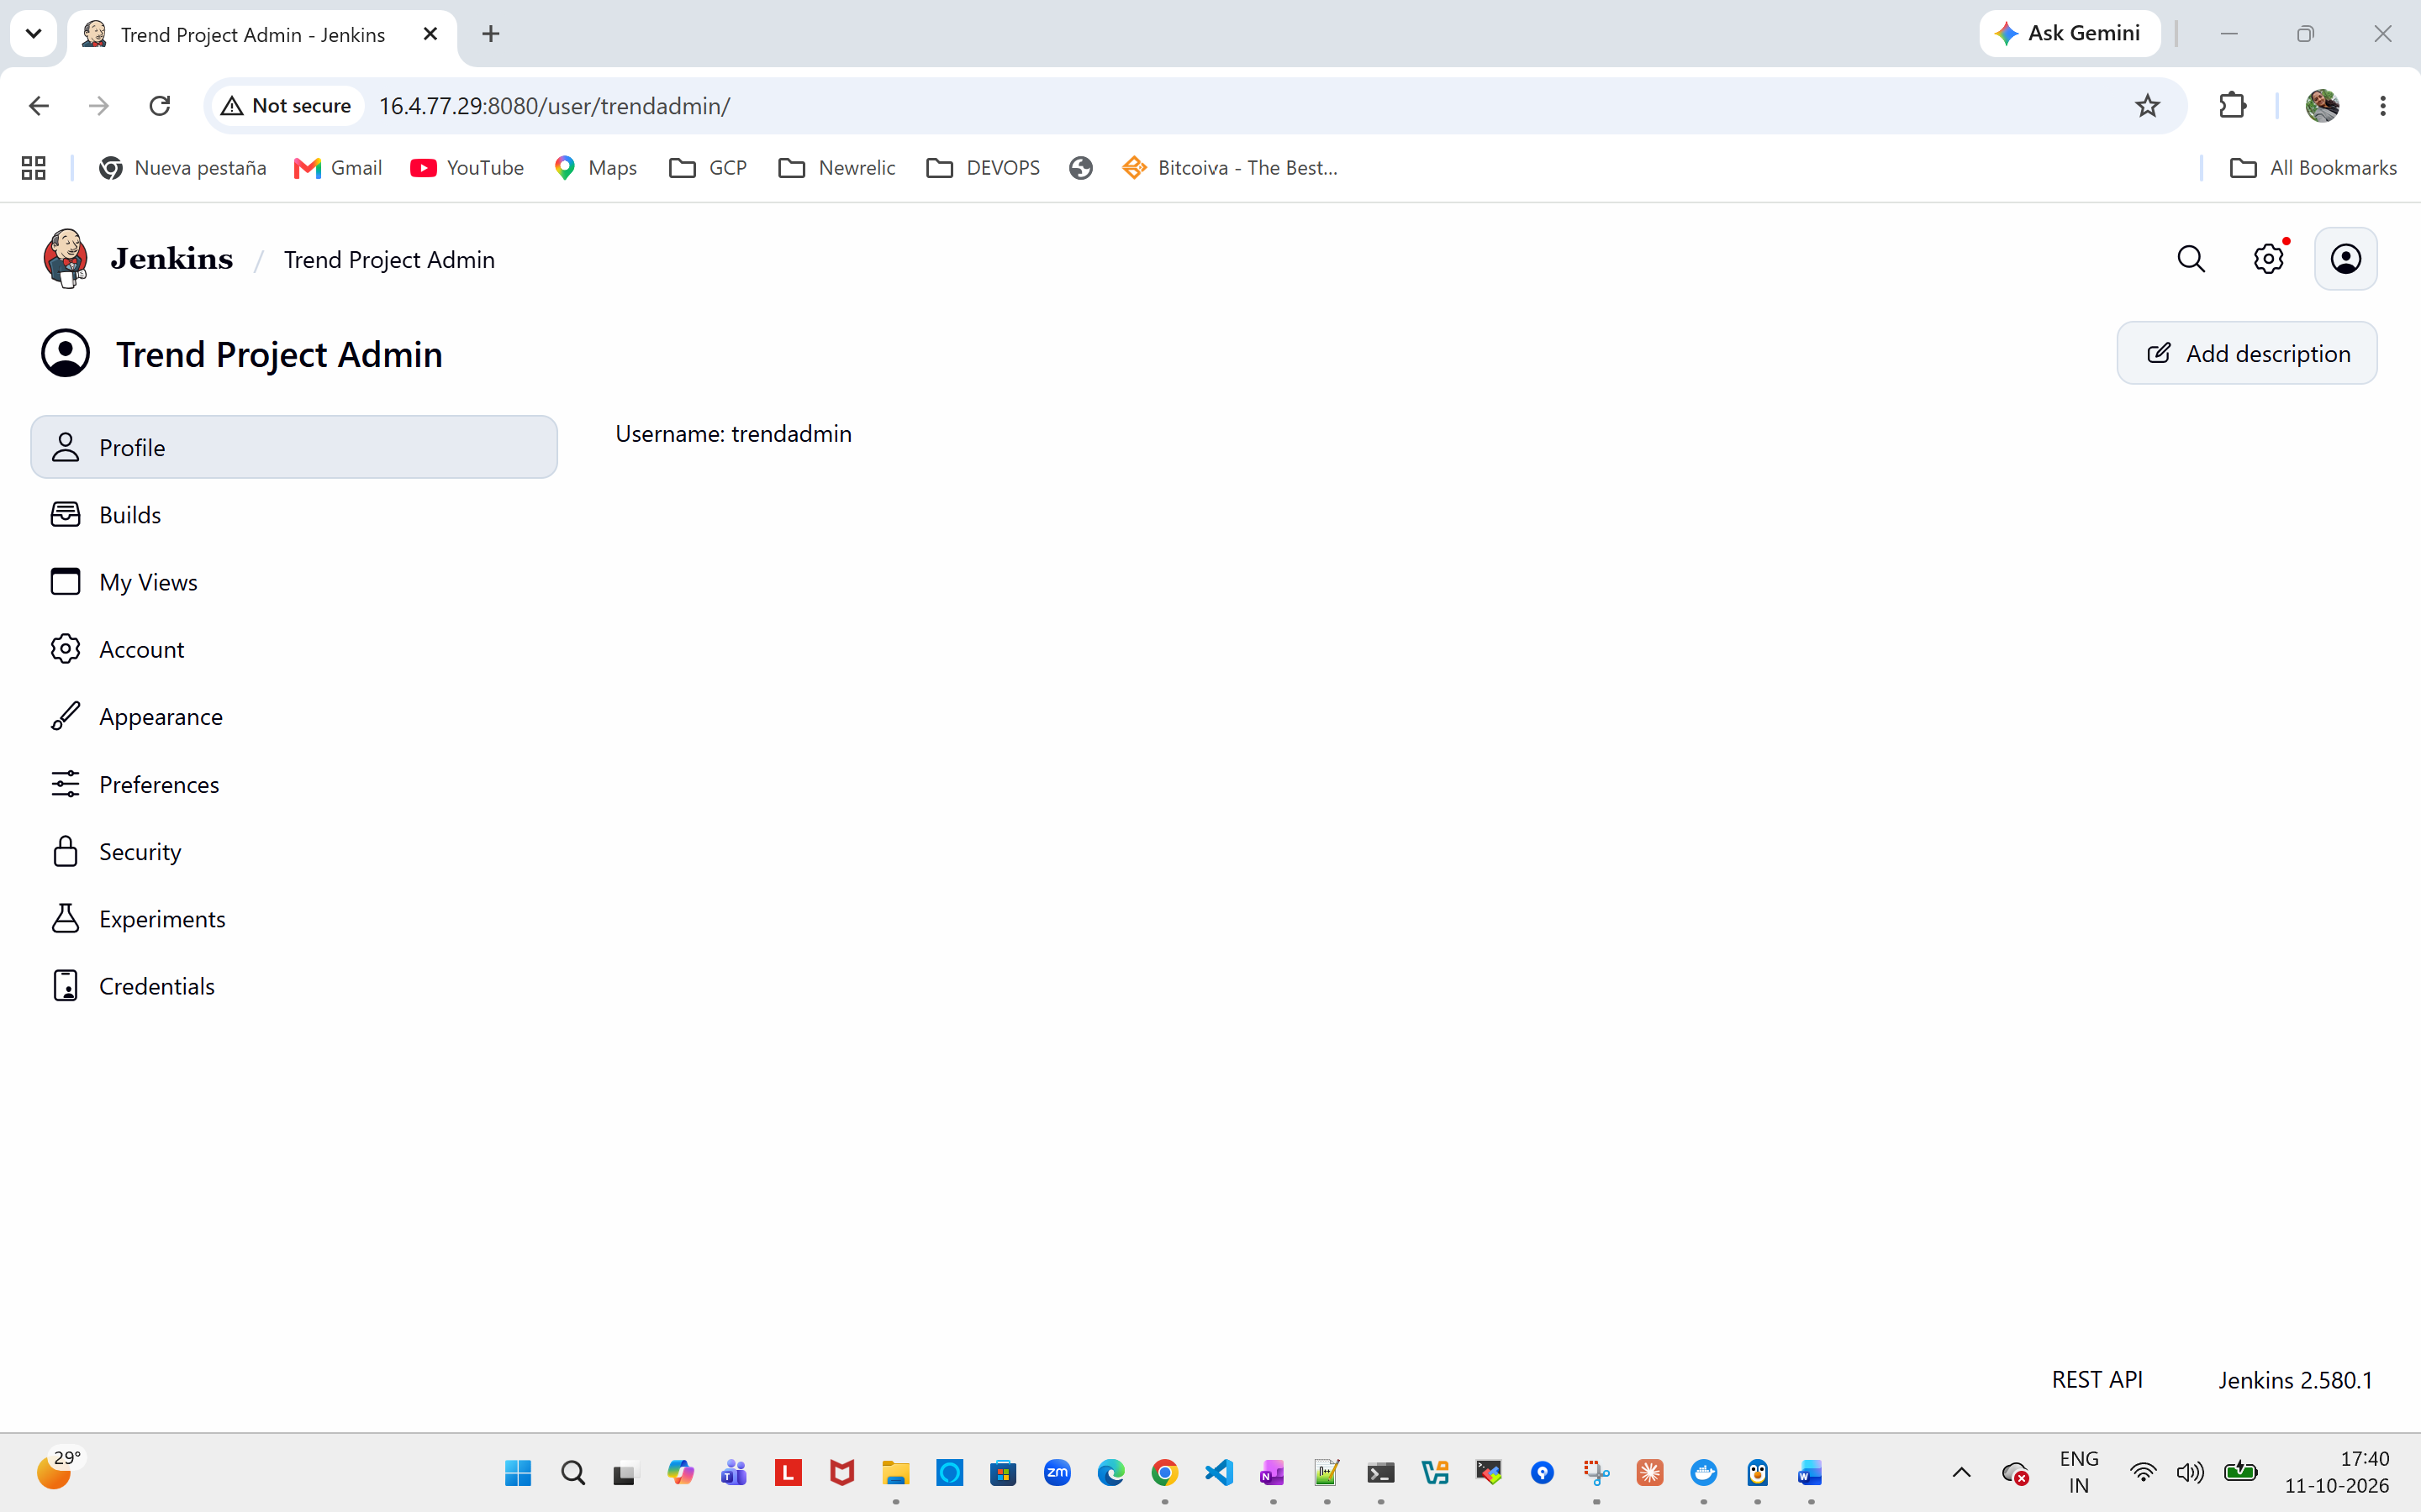

Docker installation in EC2:
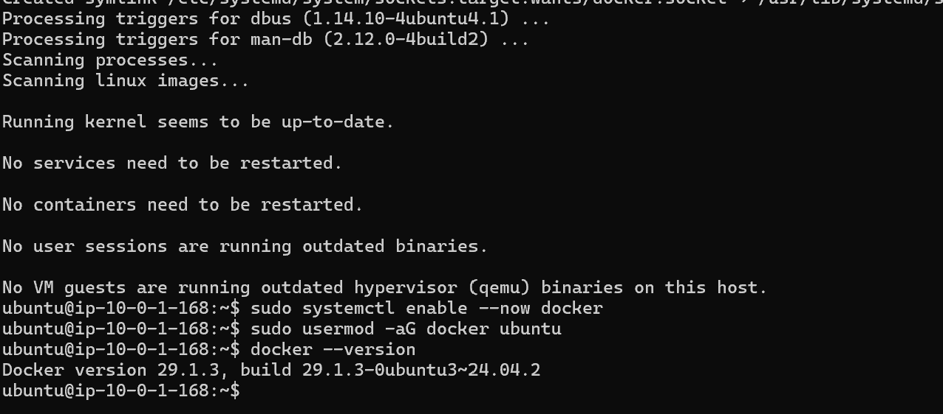

ubuntu@ip-10-0-1-168:~$ sudo -u jenkins -H docker version
Client:
Version: 29.1.3
API version: 1.52
Go version: go1.24.4
Git commit: 29.1.3-0ubuntu3~24.04.2
Built: Wed Apr 29 16:41:06 2026
OS/Arch: linux/amd64
Context: default

Server:
Engine:
Version: 29.1.3
API version: 1.52 (minimum version 1.44)
Go version: go1.24.4
Git commit: 29.1.3-0ubuntu3~24.04.2
Built: Wed Apr 29 16:41:06 2026
OS/Arch: linux/amd64
Experimental: false
containerd:
Version: 2.2.1
GitCommit:
runc:
Version: 1.3.4-0ubuntu1~24.04.1
GitCommit:
docker-init:
Version: 0.19.0
GitCommit:

Create Jenkin file in git repo:
@'
pipeline {
agent any

environment {
DOCKERHUB_CREDENTIALS = 'dockerhub-creds'
IMAGE_NAME = 'shanmugapriya2390/trend-app'
}

stages {
stage('Checkout') {
steps {
git branch: 'main',
url: 'https://github.com/Shanmugapriya2390/Trend-DevOps-Project.git'
}
}

stage('Build Docker Image') {
steps {
sh 'docker build -t ${IMAGE_NAME}:${BUILD_NUMBER} -t ${IMAGE_NAME}:latest .'
}
}

stage('Push to Docker Hub') {
steps {
withCredentials([usernamePassword(
credentialsId: "${DOCKERHUB_CREDENTIALS}",
usernameVariable: 'DOCKERHUB_USER',
passwordVariable: 'DOCKERHUB_TOKEN'
)]) {
sh '''
echo "$DOCKERHUB_TOKEN" | docker login -u "$DOCKERHUB_USER" --password-stdin
docker push "${IMAGE_NAME}:${BUILD_NUMBER}"
docker push "${IMAGE_NAME}:latest"
docker logout
'''
}
}
}
}

post {
always {
sh 'docker image prune -f'
}
}
}
'@ | Set-Content -Encoding ascii .\Jenkinsfile

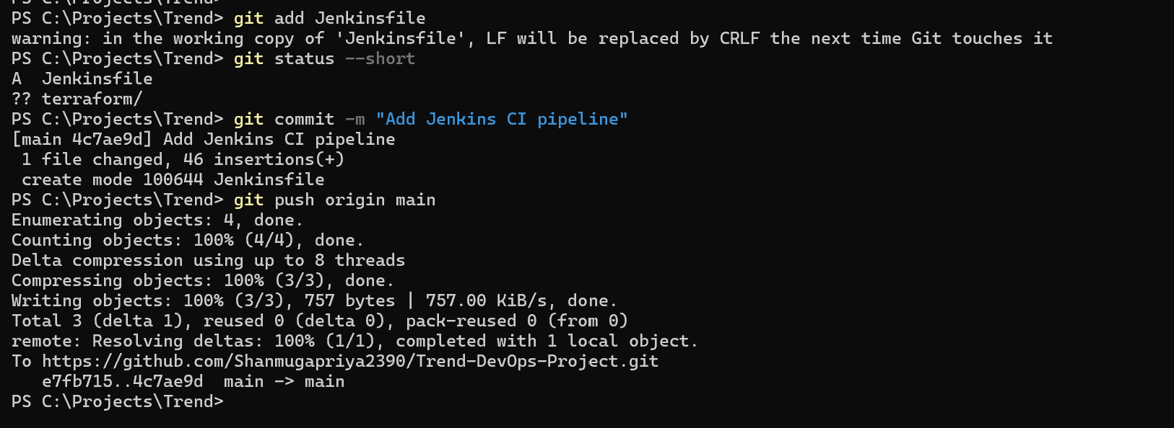

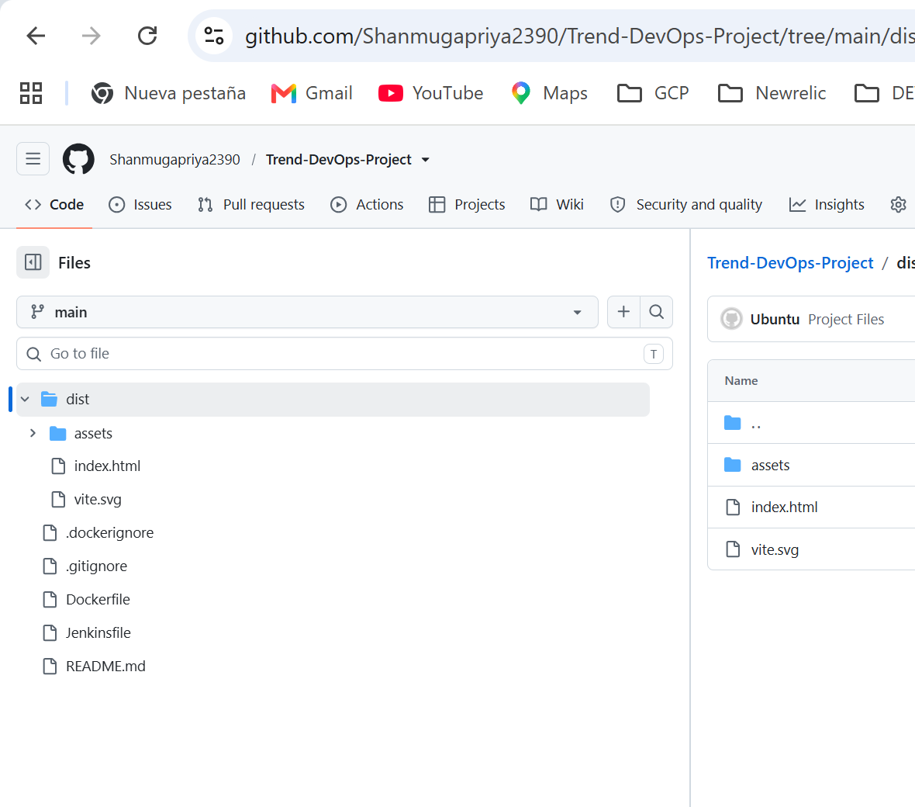

Test build POC:
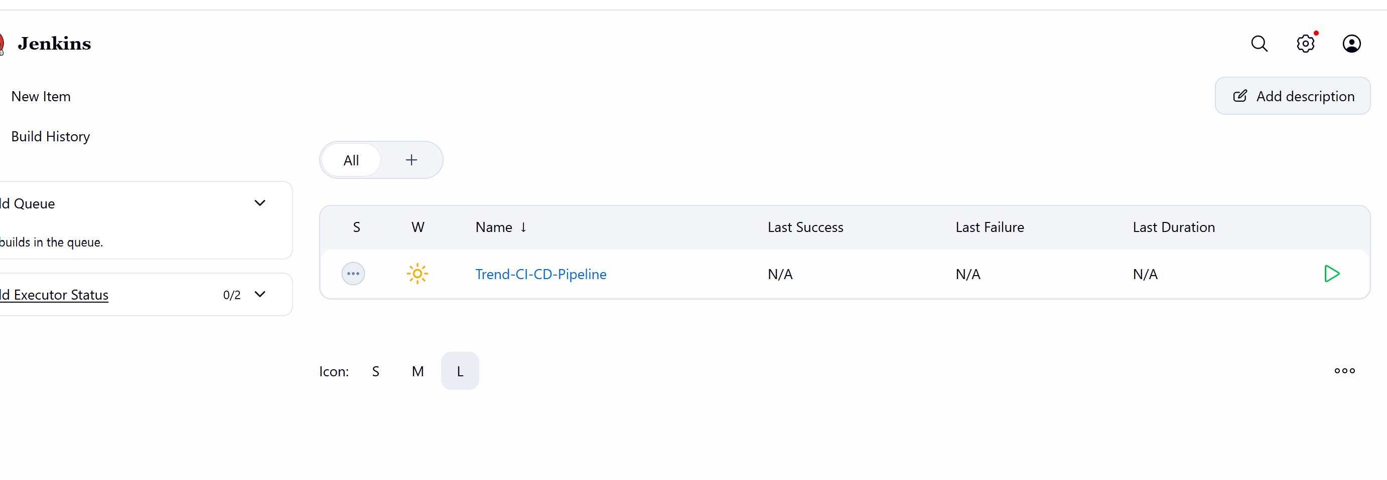
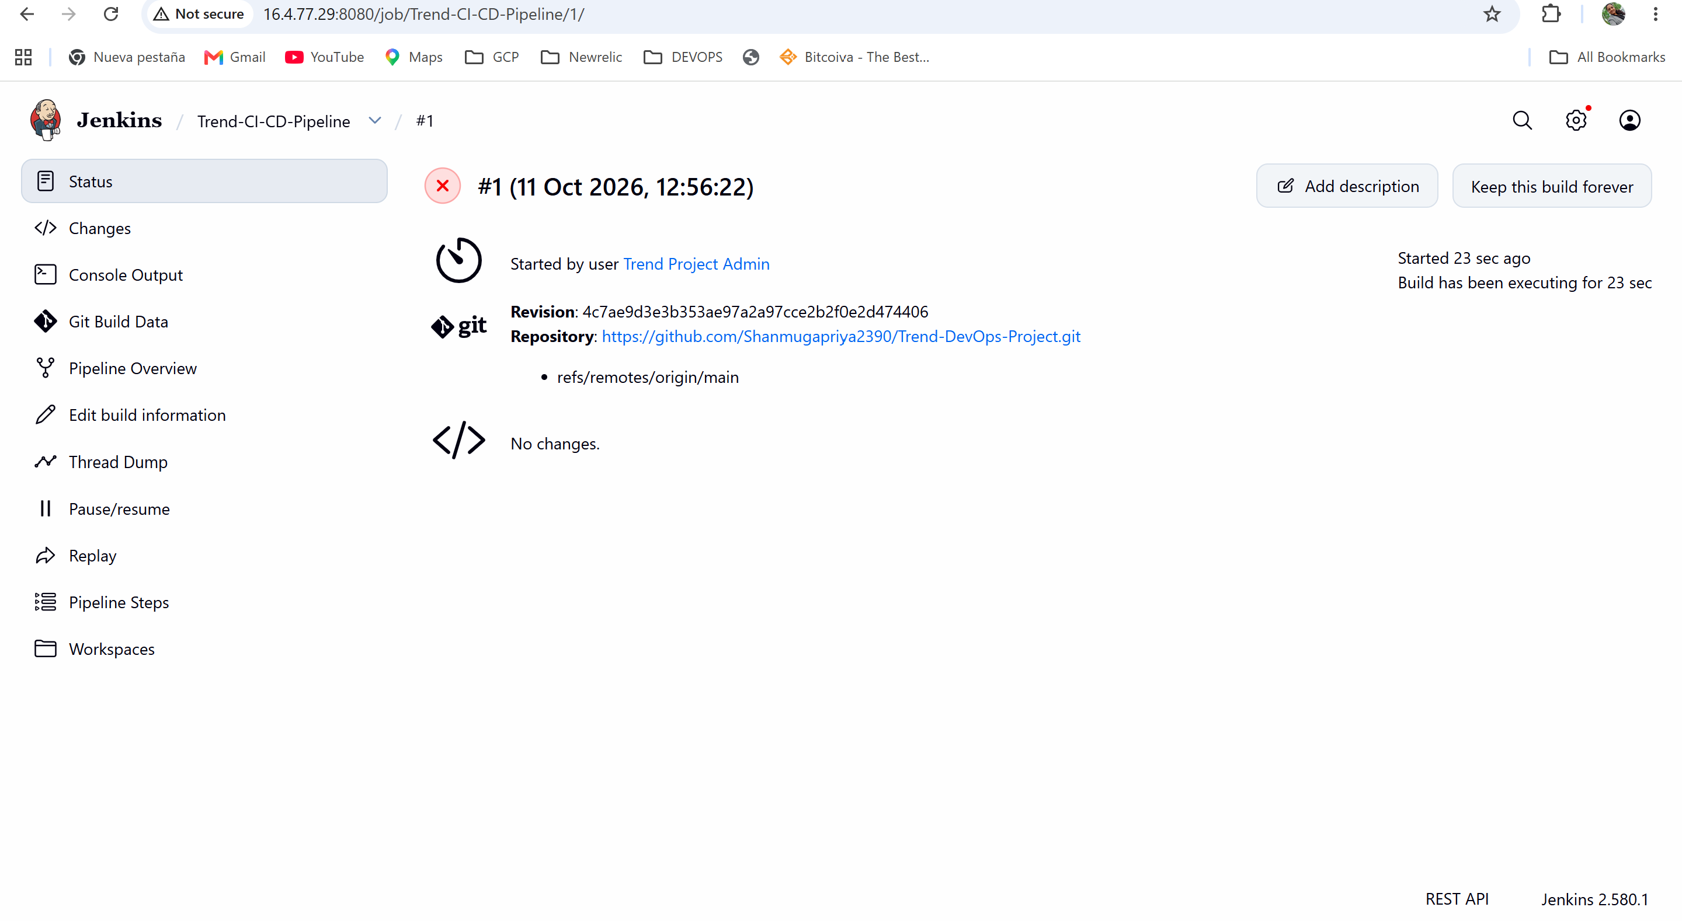
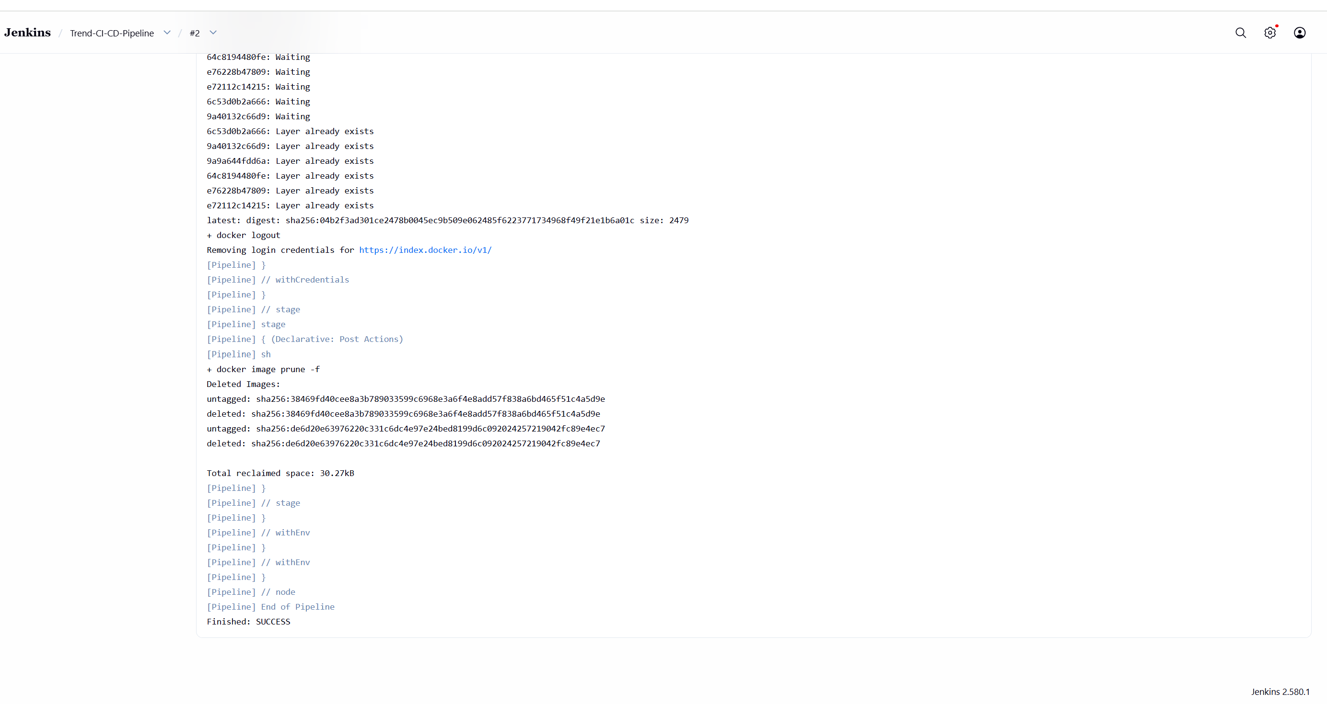

Prepare deployment to Kubernetes:
Create EKS Cluster:
PS C:\Projects\Trend> eksctl create cluster `
>> --name trend-eks-cluster `
>> --region ap-south-1 `
>> --vpc-public-subnets subnet-066d8a51e30304658,subnet-0b418b87800a23ec1 `
>> --nodegroup-name trend-workers `
>> --node-type t3.small `
>> --nodes 2 `
>> --nodes-min 2 `
>> --nodes-max 2 `
>> --managed
2026-10-11 18:53:51 [ℹ] eksctl version 0.230.0
2026-10-11 18:53:51 [ℹ] using region ap-south-1
2026-10-11 18:53:51 [✔] using existing VPC (vpc-019511a5513f85b27) and subnets (private:map[] public:map[ap-south-1a:{subnet-0b418b87800a23ec1 ap-south-1a 172.31.32.0/20 0 } ap-south-1b:{subnet-066d8a51e30304658 ap-south-1b 172.31.0.0/20 0 }])
2026-10-11 18:53:51 [!] custom VPC/subnets will be used; if resulting cluster doesn't function as expected, make sure to review the configuration of VPC/subnets
2026-10-11 18:53:51 [ℹ] nodegroup "trend-workers" will use "" [AmazonLinux2023/1.34]
2026-10-11 18:53:51 [!] Auto Mode will be enabled by default in an upcoming release of eksctl. This means managed node groups and managed networking add-ons will no longer be created by default. To maintain current behavior, explicitly set 'autoModeConfig.enabled: false' in your cluster configuration. Learn more: https://eksctl.io/usage/auto-mode/
2026-10-11 18:53:51 [ℹ] using Kubernetes version 1.34
2026-10-11 18:53:51 [ℹ] creating EKS cluster "trend-eks-cluster" in "ap-south-1" region with managed nodes
2026-10-11 18:53:51 [ℹ] will create 2 separate CloudFormation stacks for cluster itself and the initial managed nodegroup
2026-10-11 18:53:51 [ℹ] if you encounter any issues, check CloudFormation console or try 'eksctl utils describe-stacks --region=ap-south-1 --cluster=trend-eks-cluster'
2026-10-11 18:53:51 [ℹ] Kubernetes API endpoint access will use default of {publicAccess=true, privateAccess=false} for cluster "trend-eks-cluster" in "ap-south-1"
2026-10-11 18:53:51 [ℹ] CloudWatch logging will not be enabled for cluster "trend-eks-cluster" in "ap-south-1"
2026-10-11 18:53:51 [ℹ] you can enable it with 'eksctl utils update-cluster-logging --enable-types={SPECIFY-YOUR-LOG-TYPES-HERE (e.g. all)} --region=ap-south-1 --cluster=trend-eks-cluster'
2026-10-11 18:53:51 [ℹ] default addons vpc-cni, kube-proxy, coredns, metrics-server were not specified, will install them as EKS addons
2026-10-11 18:53:51 [ℹ]
2 sequential tasks: { create cluster control plane "trend-eks-cluster",
2 sequential sub-tasks: {
2 sequential sub-tasks: {
1 task: { create addons },
wait for control plane to become ready,
},
create managed nodegroup "trend-workers",
}
}
2026-10-11 18:53:51 [ℹ] building cluster stack "eksctl-trend-eks-cluster-cluster"
2026-10-11 18:53:52 [ℹ] deploying stack "eksctl-trend-eks-cluster-cluster"
2026-10-11 18:54:22 [ℹ] waiting for CloudFormation stack "eksctl-trend-eks-cluster-cluster"
2026-10-11 18:54:52 [ℹ] waiting for CloudFormation stack "eksctl-trend-eks-cluster-cluster"
2026-10-11 18:55:52 [ℹ] waiting for CloudFormation stack "eksctl-trend-eks-cluster-cluster"
2026-10-11 18:56:52 [ℹ] waiting for CloudFormation stack "eksctl-trend-eks-cluster-cluster"
2026-10-11 18:57:52 [ℹ] waiting for CloudFormation stack "eksctl-trend-eks-cluster-cluster"
2026-10-11 18:58:53 [ℹ] waiting for CloudFormation stack "eksctl-trend-eks-cluster-cluster"
2026-10-11 18:59:53 [ℹ] waiting for CloudFormation stack "eksctl-trend-eks-cluster-cluster"
2026-10-11 19:00:53 [ℹ] waiting for CloudFormation stack "eksctl-trend-eks-cluster-cluster"
2026-10-11 19:01:53 [ℹ] waiting for CloudFormation stack "eksctl-trend-eks-cluster-cluster"
2026-10-11 19:01:54 [!] recommended policies were found for "vpc-cni" addon, but since OIDC is disabled on the cluster, eksctl cannot configure the requested permissions; the recommended way to provide IAM permissions for "vpc-cni" addon is via pod identity associations; after addon creation is completed, add all recommended policies to the config file, under `addon.PodIdentityAssociations`, and run `eksctl update addon`
2026-10-11 19:01:54 [ℹ] creating addon: vpc-cni
2026-10-11 19:01:54 [ℹ] successfully created addon: vpc-cni
2026-10-11 19:01:55 [ℹ] creating addon: kube-proxy
2026-10-11 19:01:55 [ℹ] successfully created addon: kube-proxy
2026-10-11 19:01:55 [ℹ] creating addon: coredns
2026-10-11 19:01:55 [ℹ] successfully created addon: coredns
2026-10-11 19:03:56 [ℹ] building managed nodegroup stack "eksctl-trend-eks-cluster-nodegroup-trend-workers"
2026-10-11 19:03:57 [ℹ] deploying stack "eksctl-trend-eks-cluster-nodegroup-trend-workers"
2026-10-11 19:03:57 [ℹ] waiting for CloudFormation stack "eksctl-trend-eks-cluster-nodegroup-trend-workers"
2026-10-11 19:04:27 [ℹ] waiting for CloudFormation stack "eksctl-trend-eks-cluster-nodegroup-trend-workers"
2026-10-11 19:05:13 [ℹ] waiting for CloudFormation stack "eksctl-trend-eks-cluster-nodegroup-trend-workers"
2026-10-11 19:06:07 [ℹ] waiting for CloudFormation stack "eksctl-trend-eks-cluster-nodegroup-trend-workers"
2026-10-11 19:06:07 [ℹ] waiting for the control plane to become ready
2026-10-11 19:06:07 [✔] saved kubeconfig as "C:\\Users\\ShanmugaPriya\\.kube\\config"
2026-10-11 19:06:07 [ℹ] no tasks
2026-10-11 19:06:07 [✔] all EKS cluster resources for "trend-eks-cluster" have been created
2026-10-11 19:06:07 [ℹ] nodegroup "trend-workers" has 2 node(s)
2026-10-11 19:06:07 [ℹ] node "ip-172-31-44-99.ap-south-1.compute.internal" is ready
2026-10-11 19:06:07 [ℹ] node "ip-172-31-6-251.ap-south-1.compute.internal" is ready
2026-10-11 19:06:07 [ℹ] waiting for at least 2 node(s) to become ready in "trend-workers"
2026-10-11 19:06:07 [ℹ] nodegroup "trend-workers" has 2 node(s)
2026-10-11 19:06:07 [ℹ] node "ip-172-31-44-99.ap-south-1.compute.internal" is ready
2026-10-11 19:06:07 [ℹ] node "ip-172-31-6-251.ap-south-1.compute.internal" is ready
2026-10-11 19:06:07 [✔] created 1 managed nodegroup(s) in cluster "trend-eks-cluster"
2026-10-11 19:06:08 [ℹ] creating addon: metrics-server
2026-10-11 19:06:08 [ℹ] successfully created addon: metrics-server
2026-10-11 19:06:09 [ℹ] kubectl command should work with "C:\\Users\\ShanmugaPriya\\.kube\\config", try 'kubectl get nodes'
2026-10-11 19:06:09 [✔] EKS cluster "trend-eks-cluster" in "ap-south-1" region is ready
PS C:\Projects\Trend>

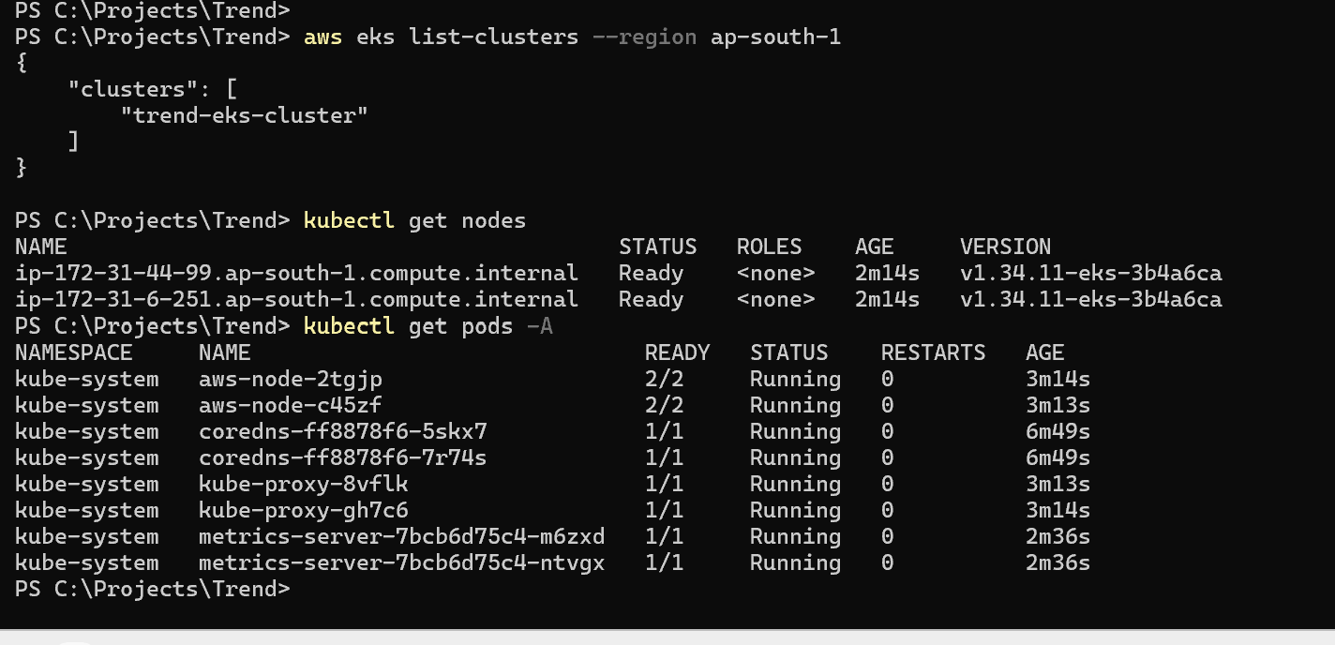

POC Test:

kubectl create deployment trend-app `
--image=shanmugapriya2390/trend-app:latest `
--replicas=2

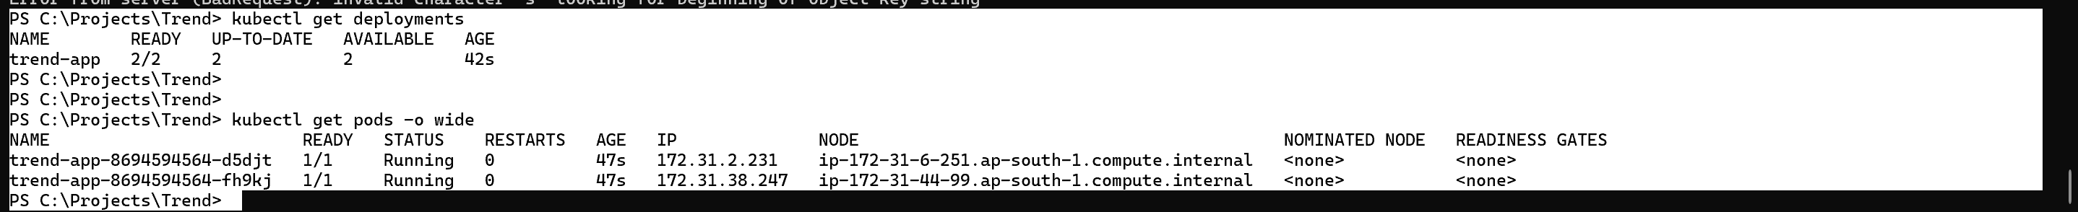

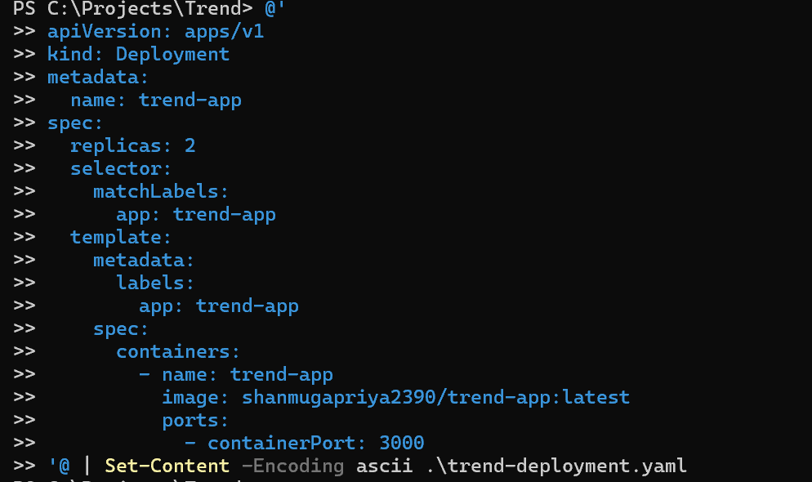

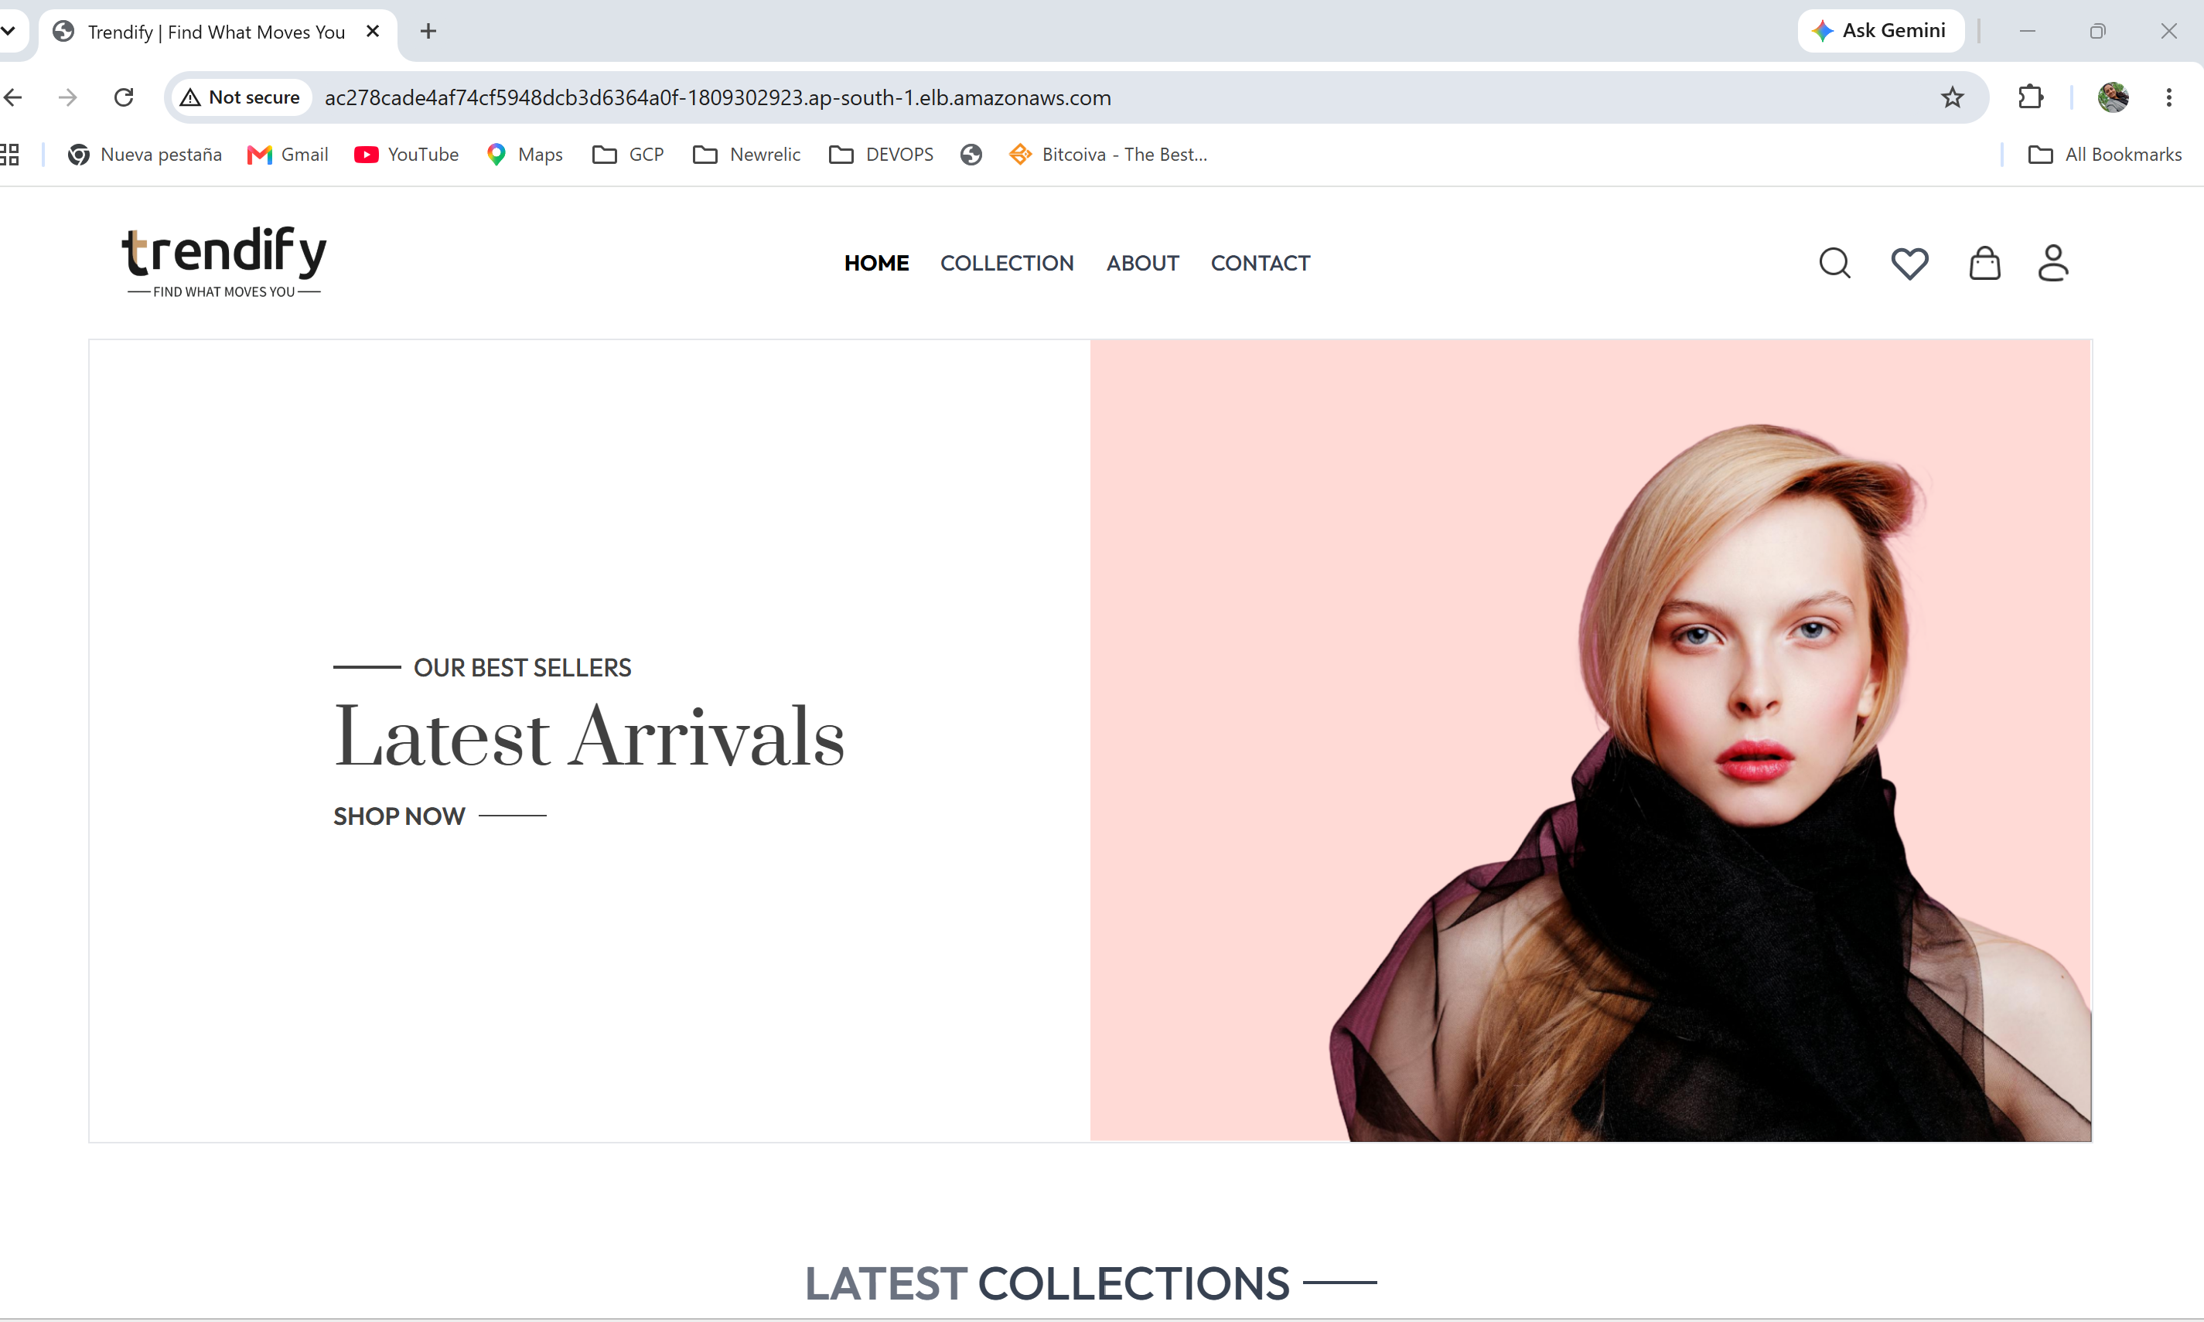

Connect Jenkins to EKS:
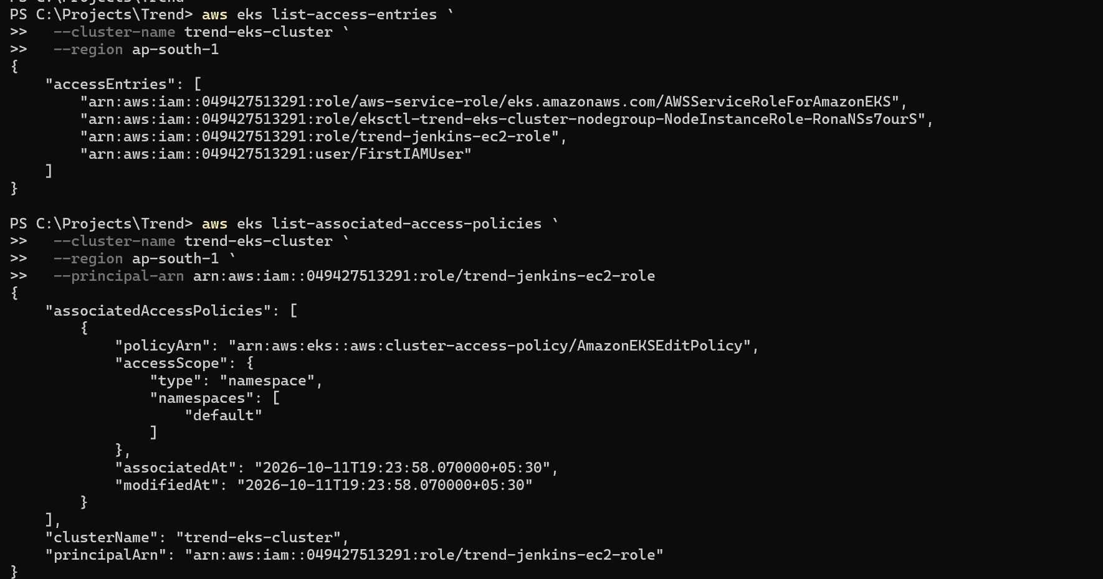

Pipeline build:
Jenkin code modified:
pipeline {
agent any

environment {
DOCKERHUB_CREDENTIALS = 'dockerhub-creds'
IMAGE_NAME = 'shanmugapriya2390/trend-app'
EKS_CLUSTER = 'trend-eks-cluster'
AWS_DEFAULT_REGION = 'ap-south-1'
}

stages {
stage('Checkout') {
steps {
git branch: 'main',
url: 'https://github.com/Shanmugapriya2390/Trend-DevOps-Project.git'
}
}

stage('Build Docker Image') {
steps {
sh '''
docker build \
-t ${IMAGE_NAME}:${BUILD_NUMBER} \
-t ${IMAGE_NAME}:latest .
'''
}
}

stage('Push to Docker Hub') {
steps {
withCredentials([usernamePassword(
credentialsId: "${DOCKERHUB_CREDENTIALS}",
usernameVariable: 'DOCKERHUB_USER',
passwordVariable: 'DOCKERHUB_TOKEN'
)]) {
sh '''
set +x
echo "$DOCKERHUB_TOKEN" | docker login \
-u "$DOCKERHUB_USER" --password-stdin

docker push "${IMAGE_NAME}:${BUILD_NUMBER}"
docker push "${IMAGE_NAME}:latest"

docker logout
'''
}
}
}

stage('Deploy to EKS') {
steps {
sh '''
set -e

aws sts get-caller-identity

kubectl set image deployment/trend-app \
trend-app=${IMAGE_NAME}:${BUILD_NUMBER} \
--namespace=default

kubectl rollout status deployment/trend-app \
--namespace=default \
--timeout=180s

kubectl get deployment trend-app \
--namespace=default
'''
}
}
}

post {
always {
sh 'docker image prune -f'
}
}
}
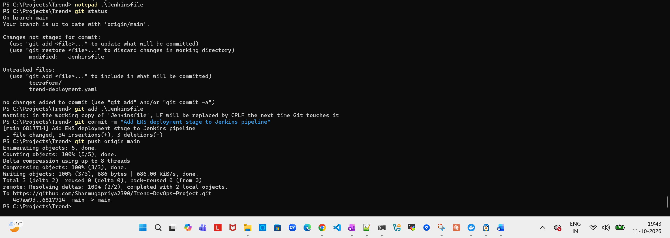

After git push, build ran successfully,

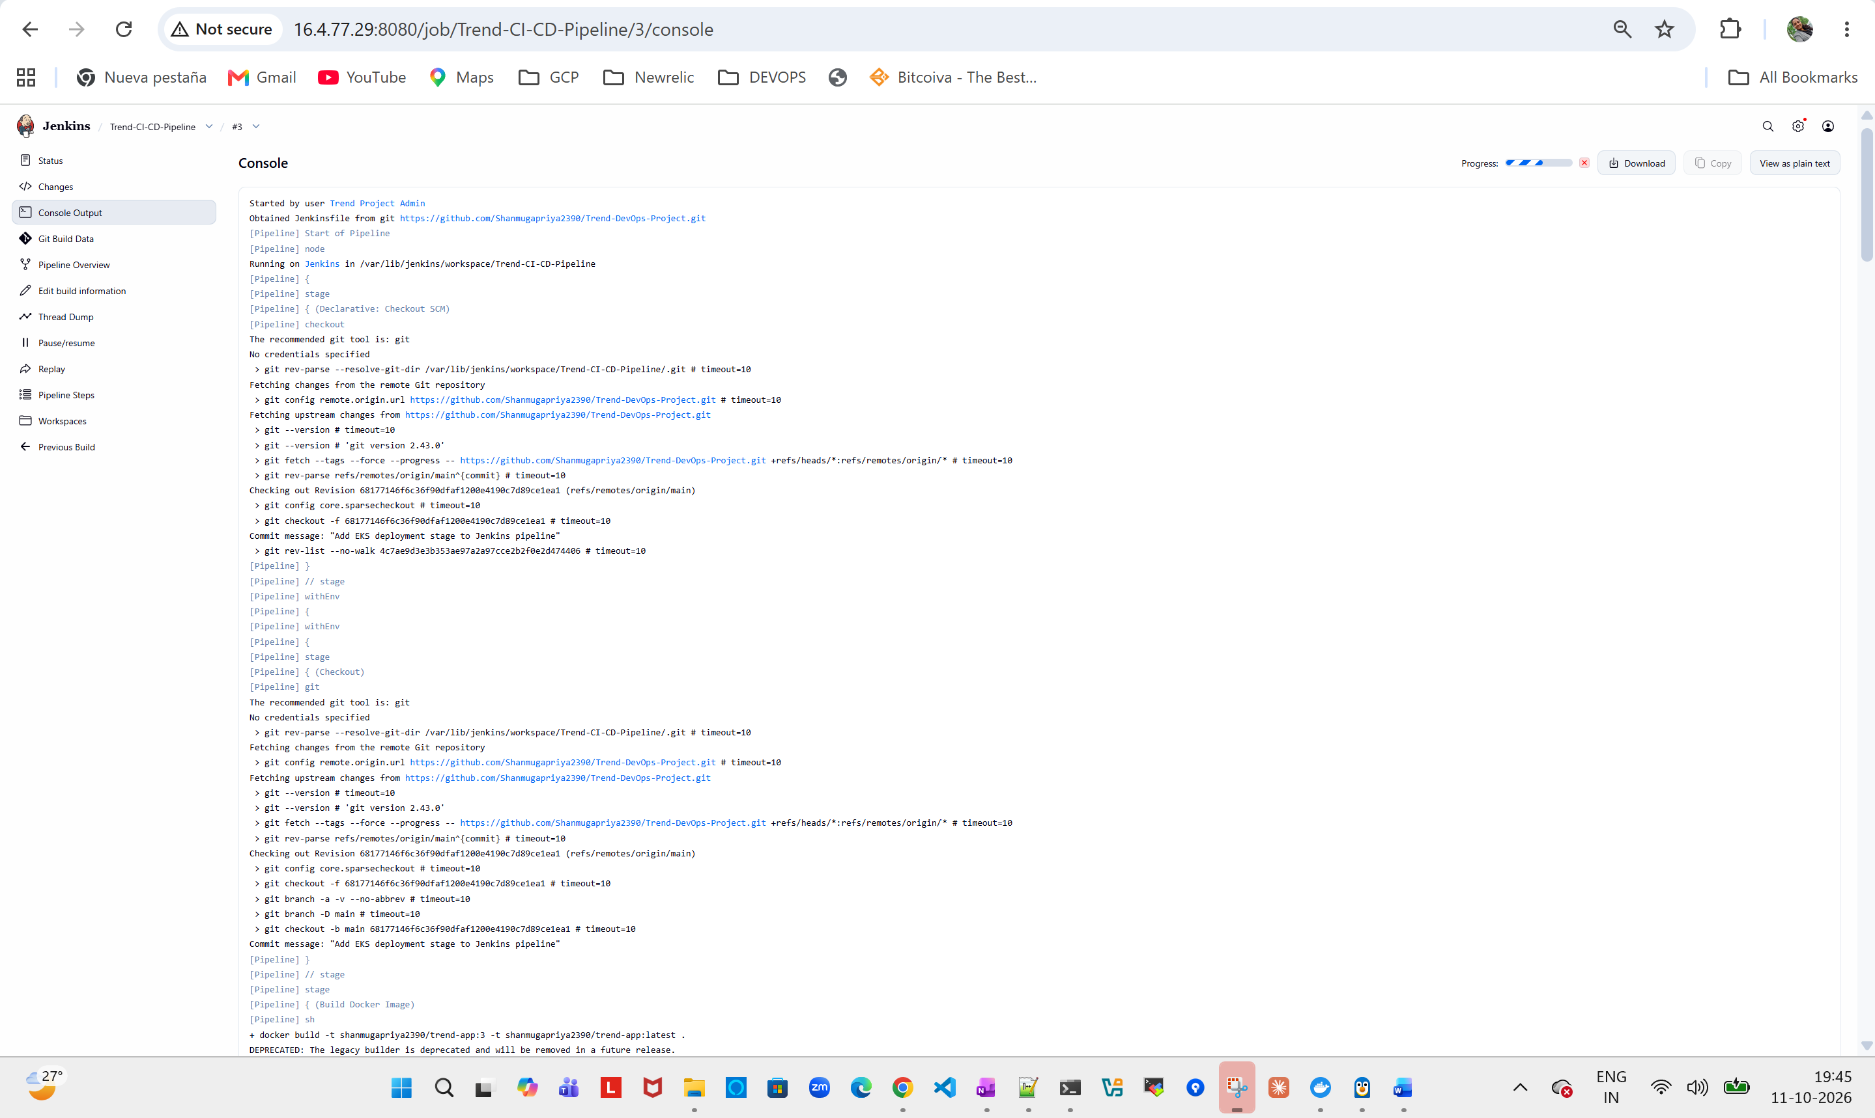
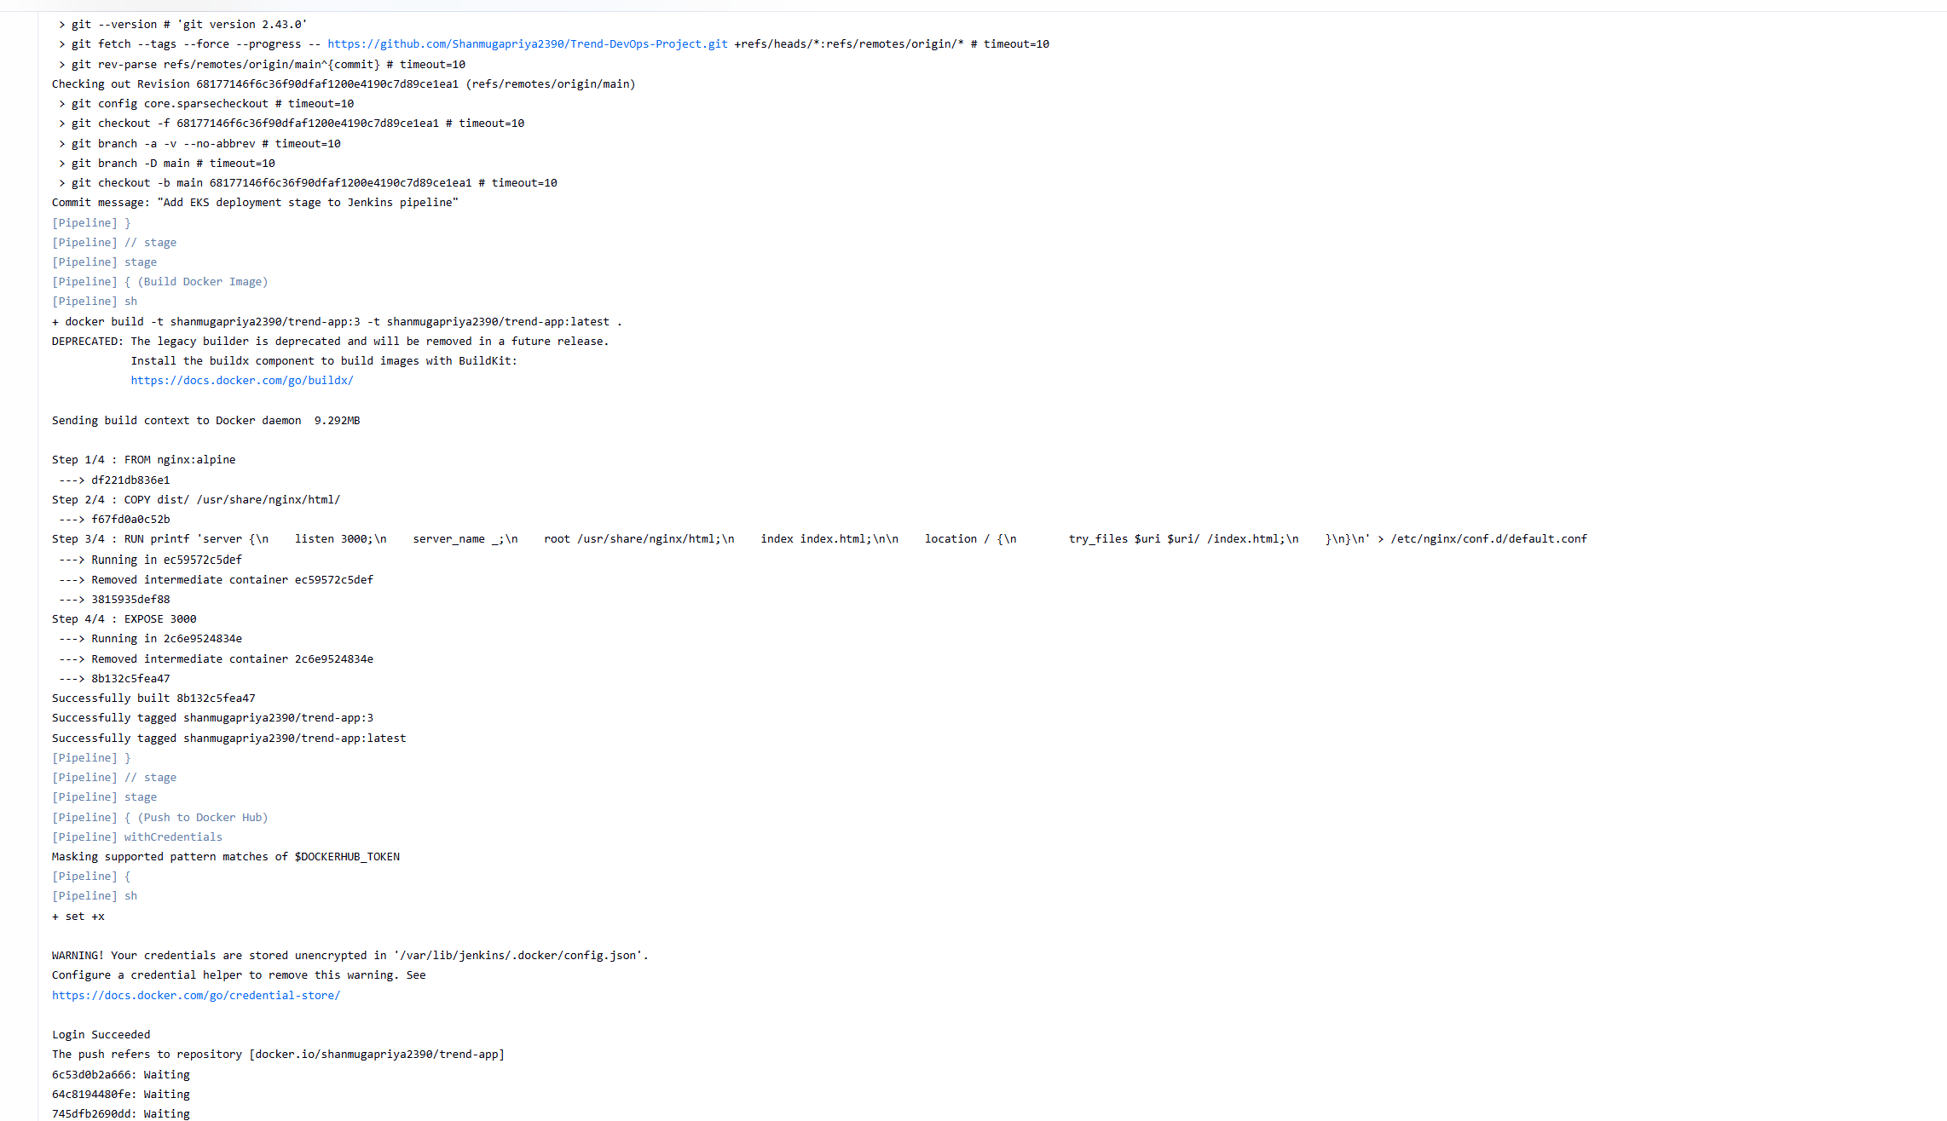
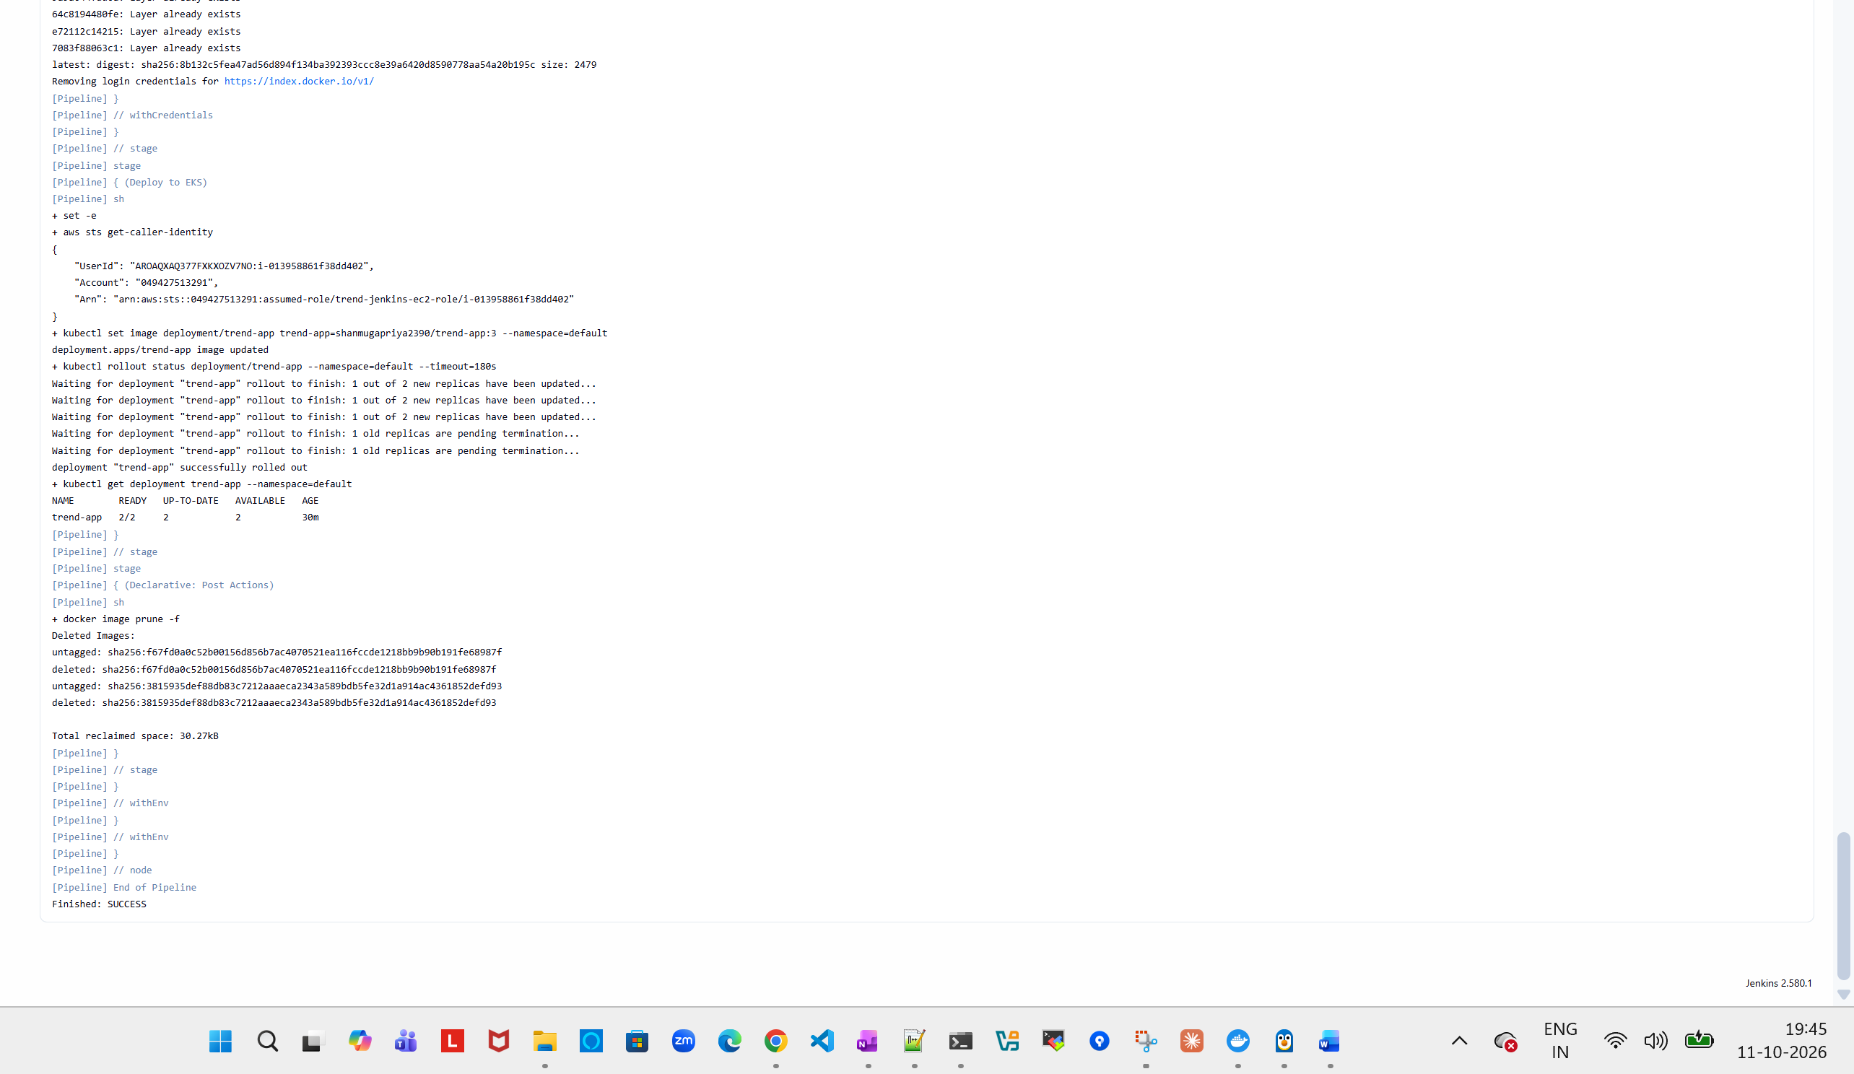

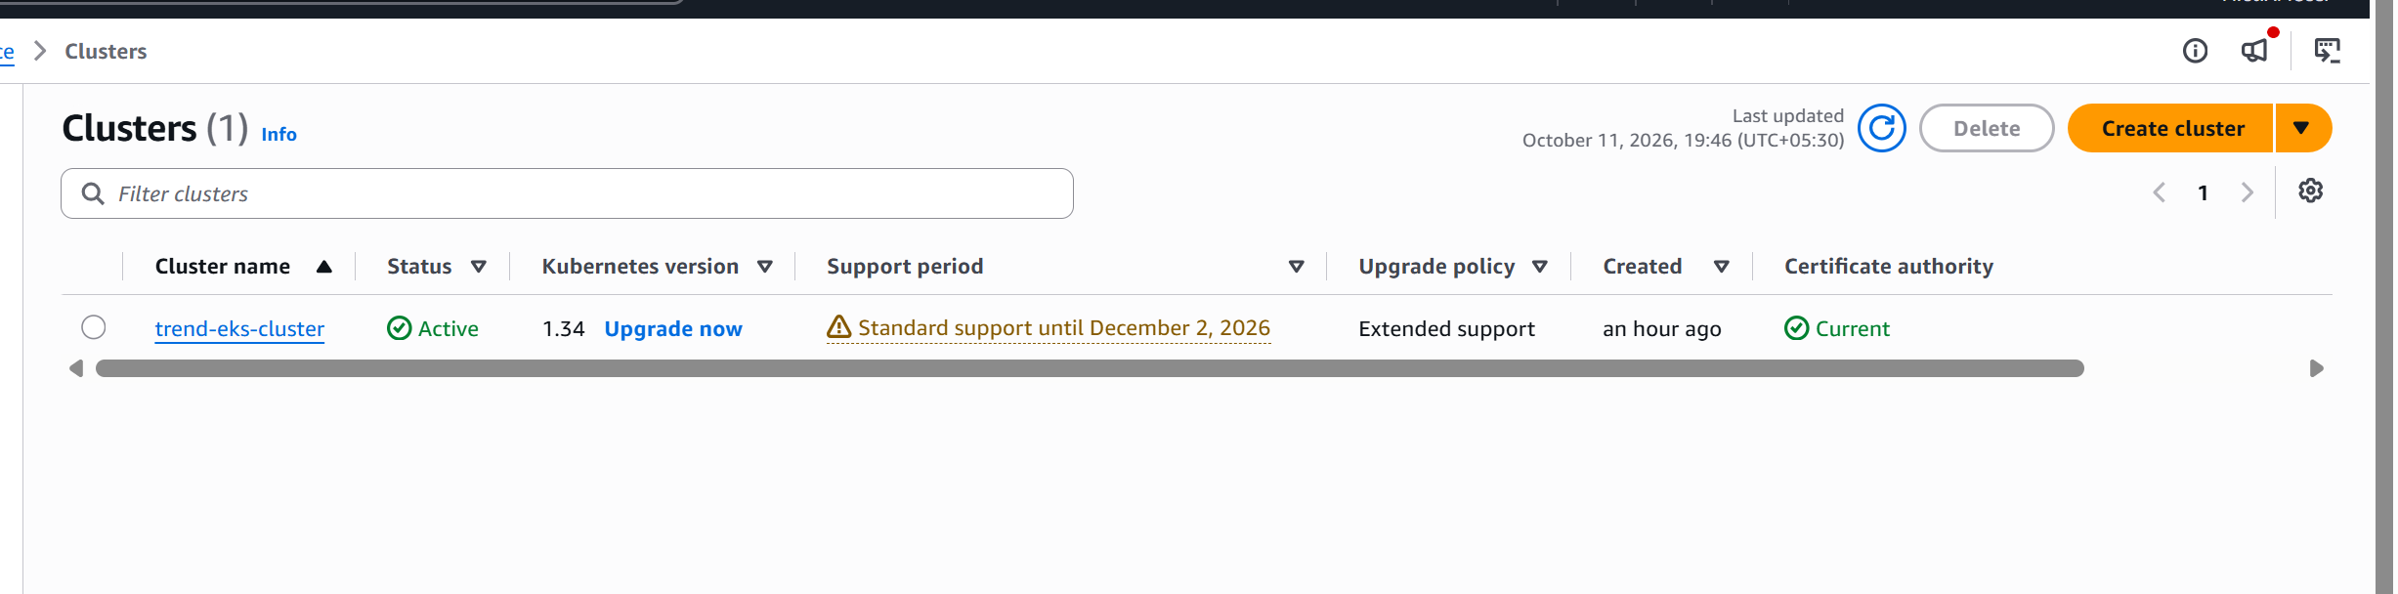

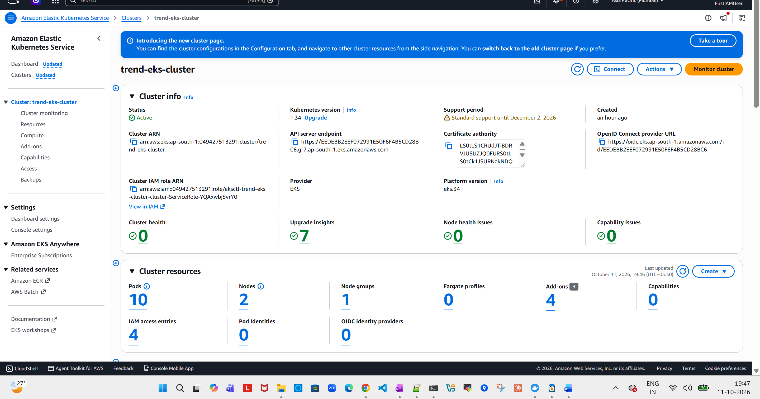
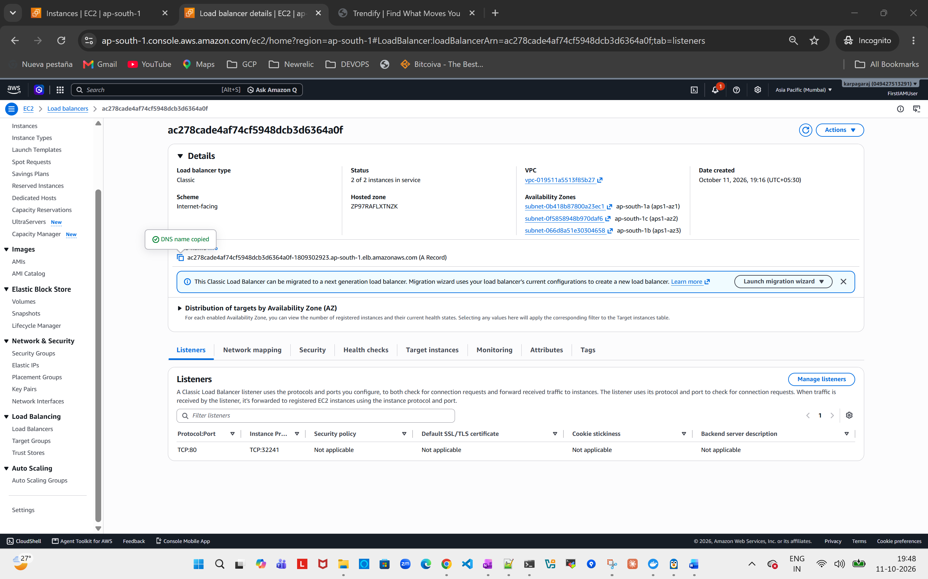
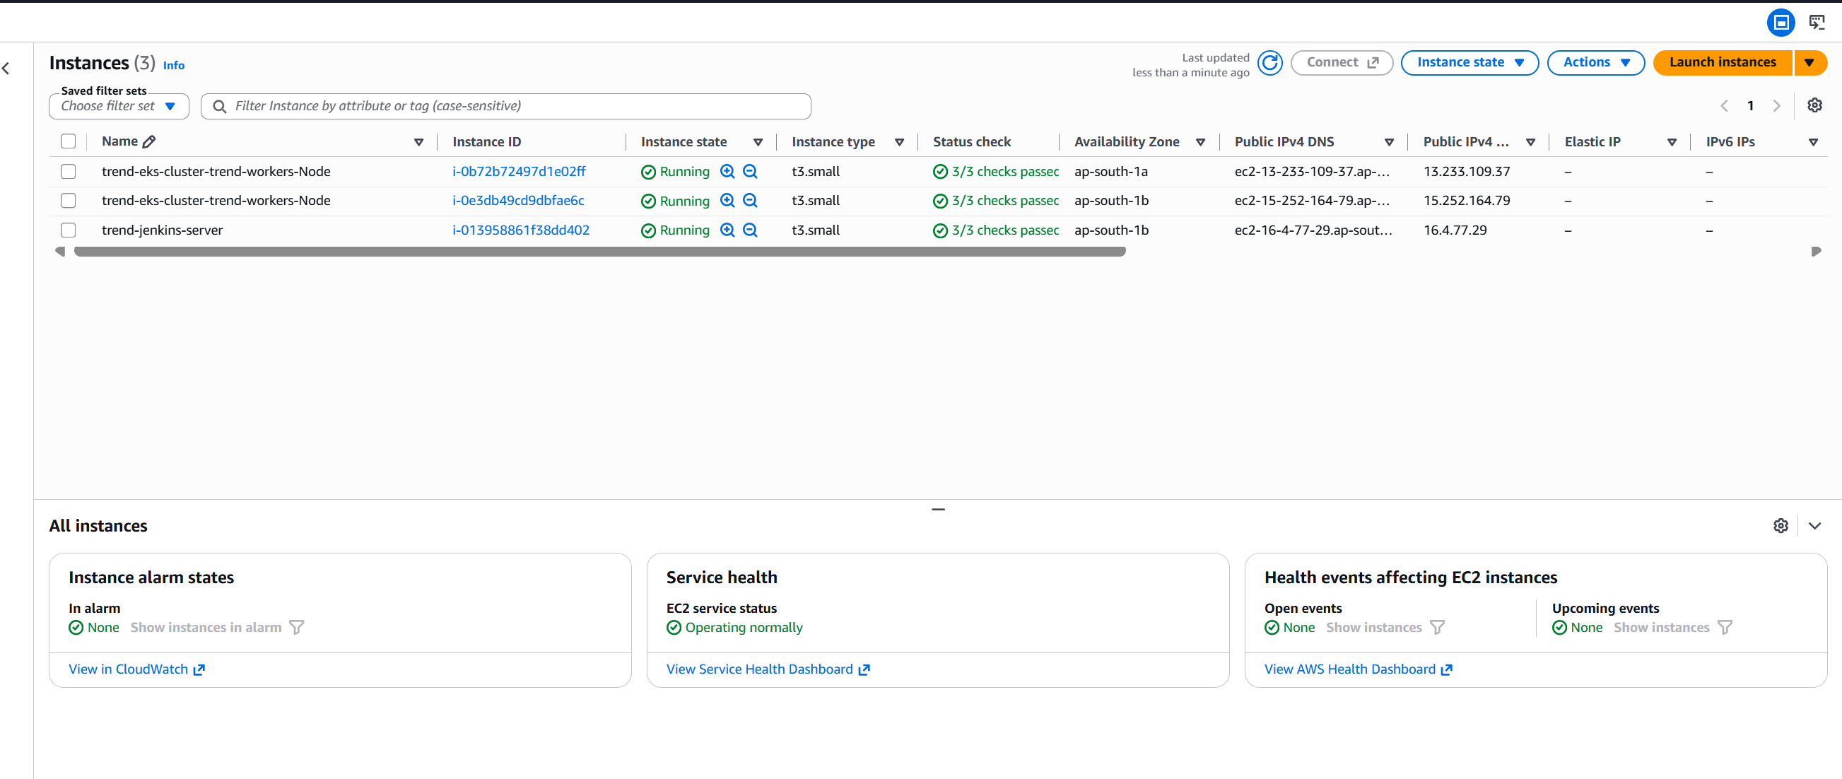

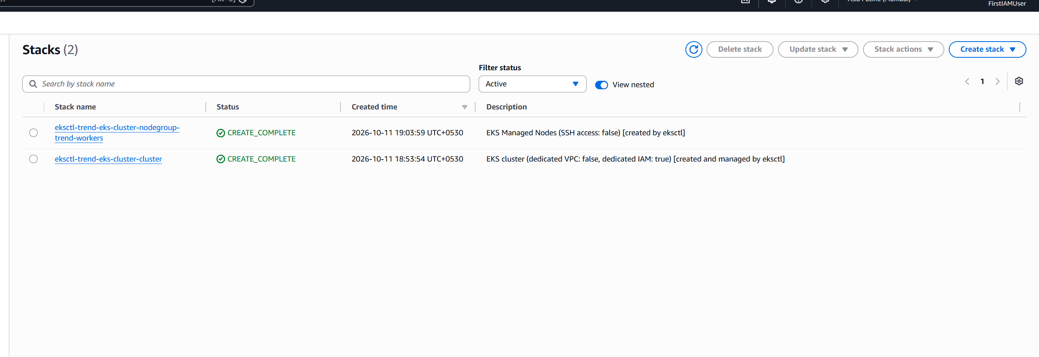

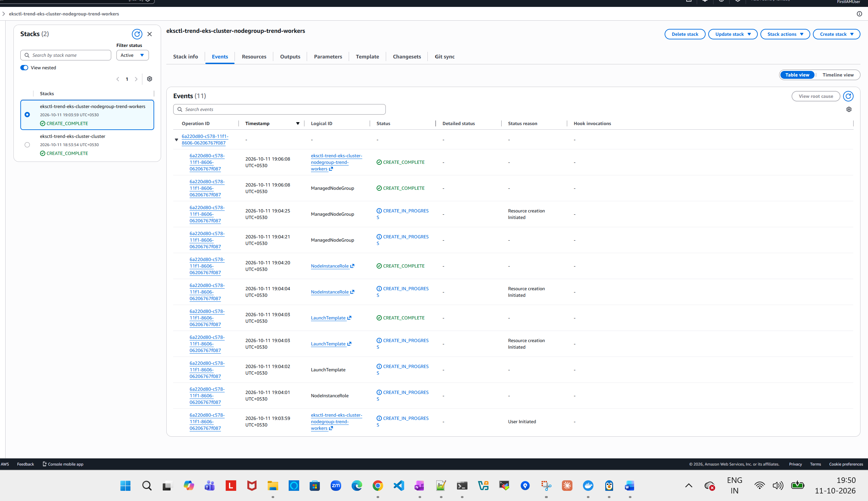



Monitoring:
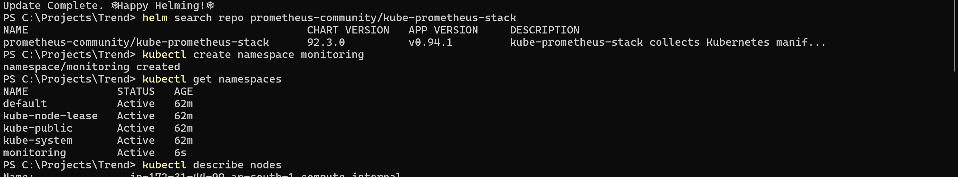
Grafana:
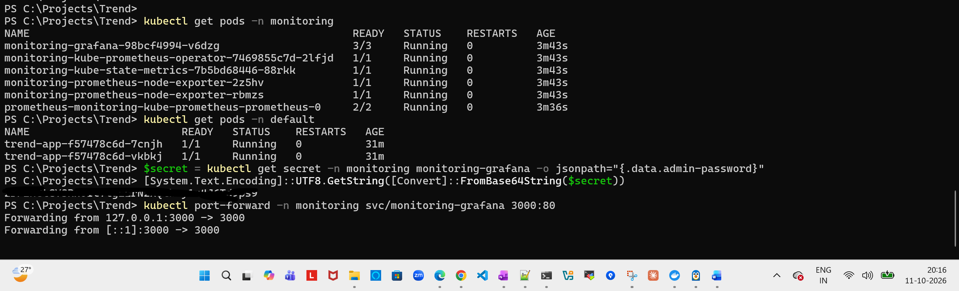

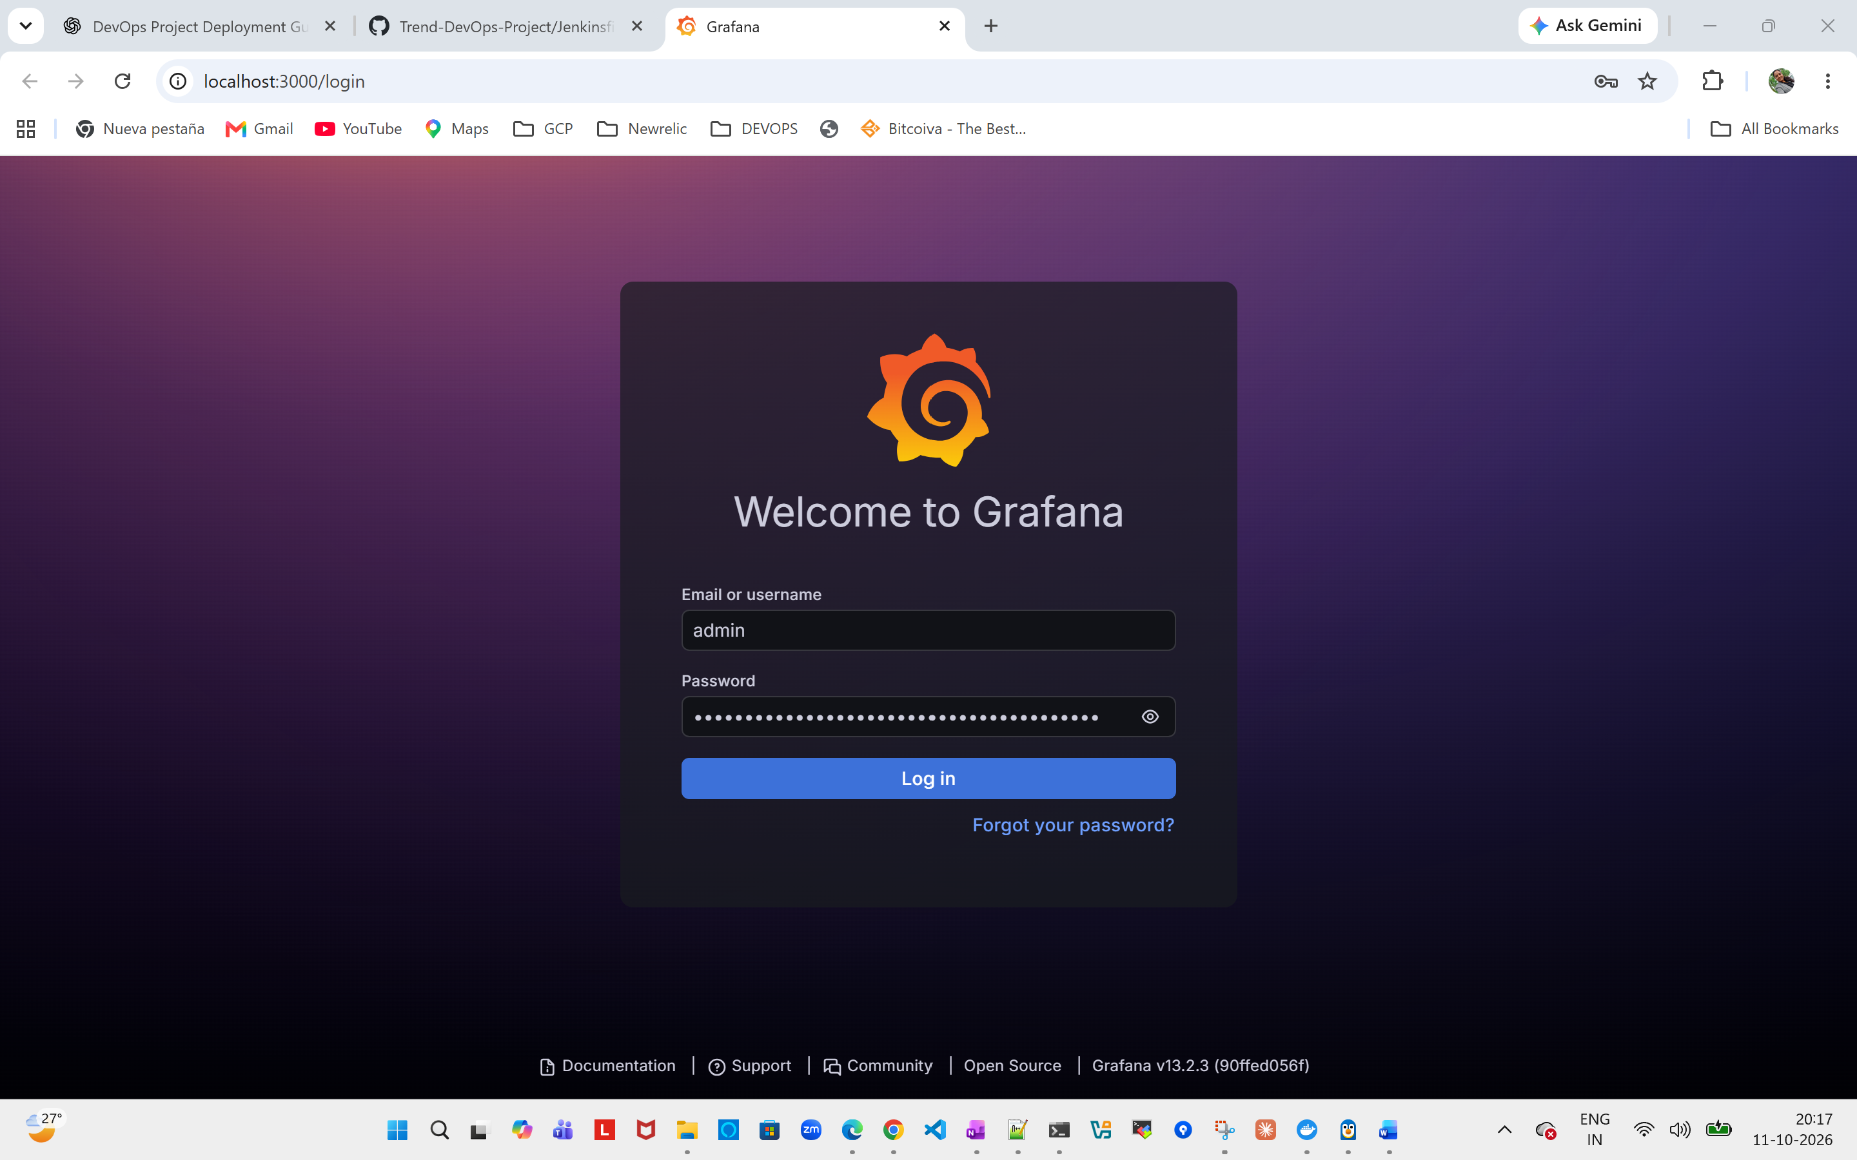

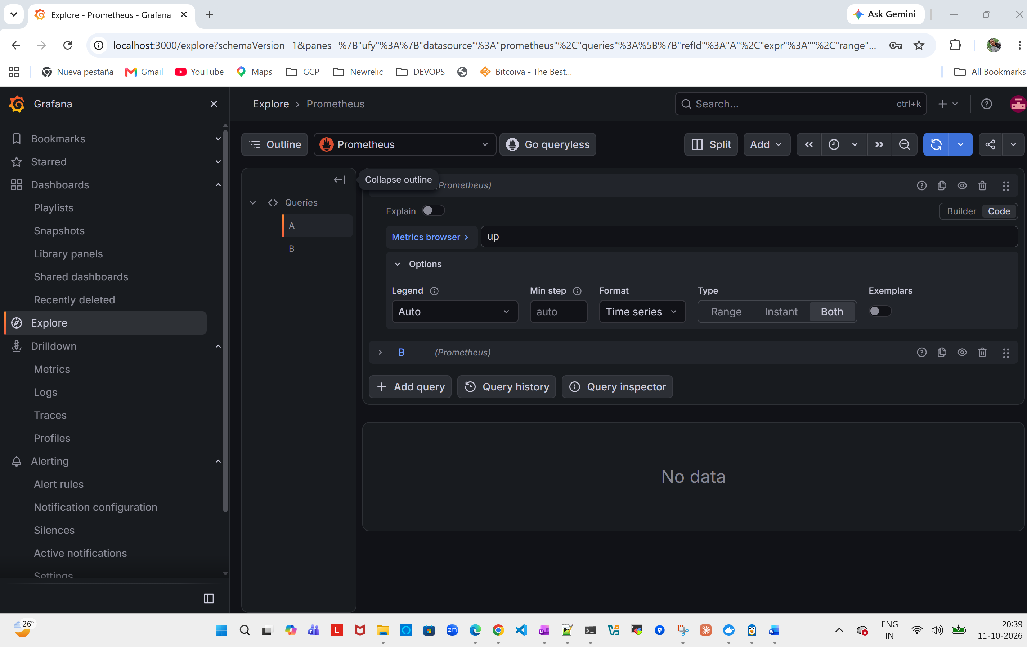
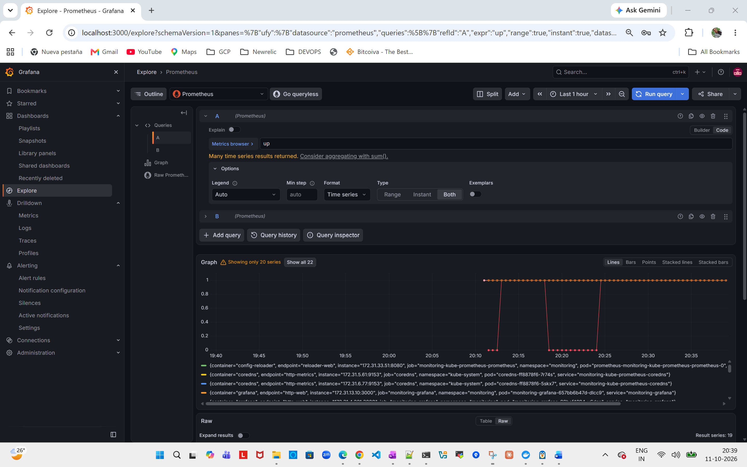

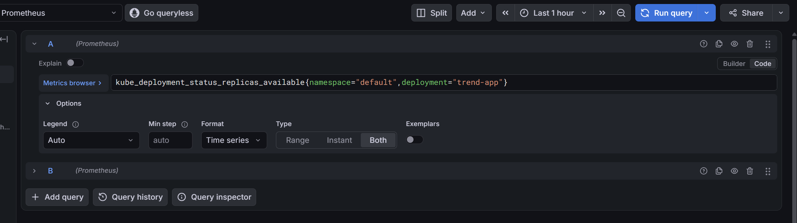

Dashboard:

